Supplementary Material

**Pancancer Network Analysis reveals key Master Regulators for Cancer Invasiveness**

**Mall et al**

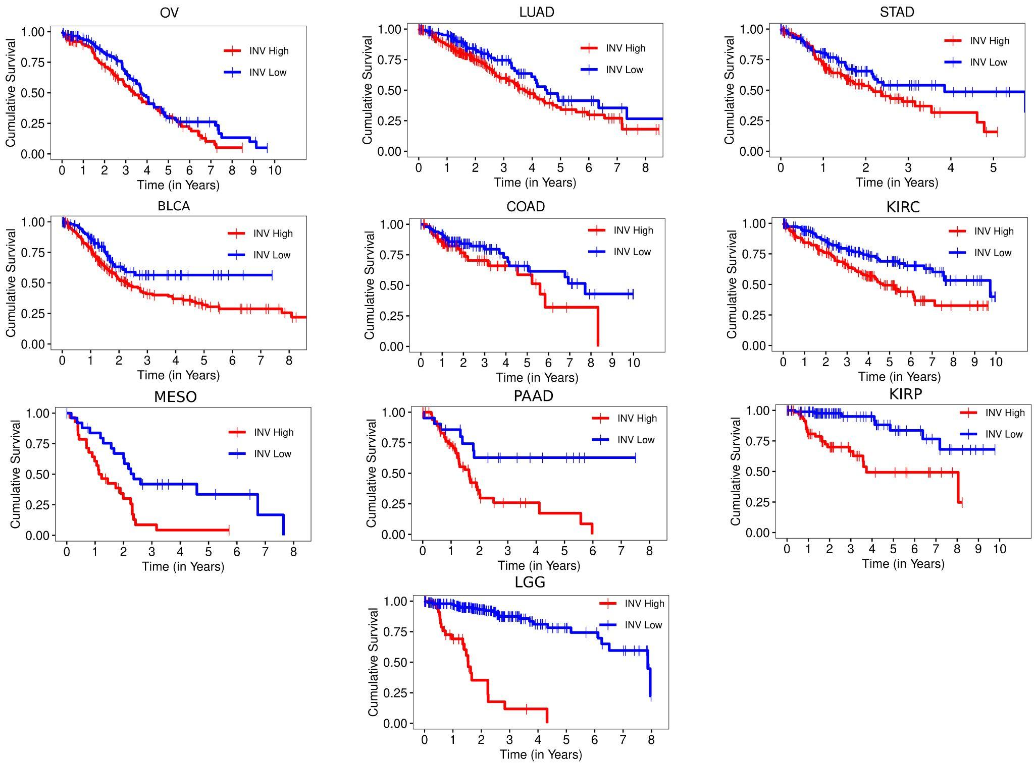

**Figure S1**: Kaplan-Meier plot highlights the difference in survival between the INV High vs INV Low groups for the 10 cancers of interest. Here OV is Ovarian Cancer, LUAD is Lung Adenocarcinoma, STAD is Stomach Adenocarcinoma, BLCA is Bladder Urothelial Carcinoma, COAD is Colon Adenocarcinoma, KIRC is Kidney Renal Cell Carcinoma, MESO is Mesothelioma, PAAD is Pancreatic Adenocarcinoma, KIRP is Kidney Renal Papillary Cell Carcinoma and LGG is Low Grade Gliomas.

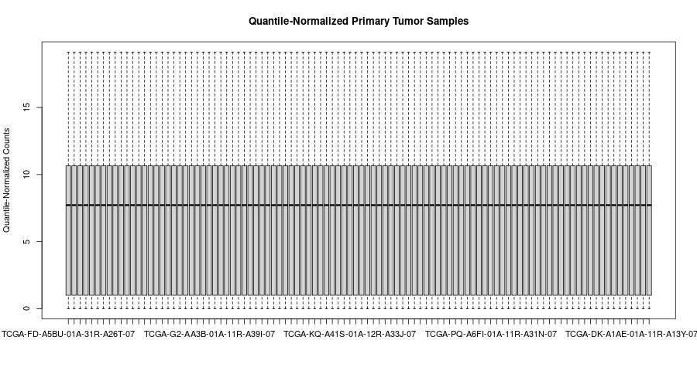

**Figure S2**: Quantile-Normalized and log2 transformed gene expression profiles for BLCA tumor samples.

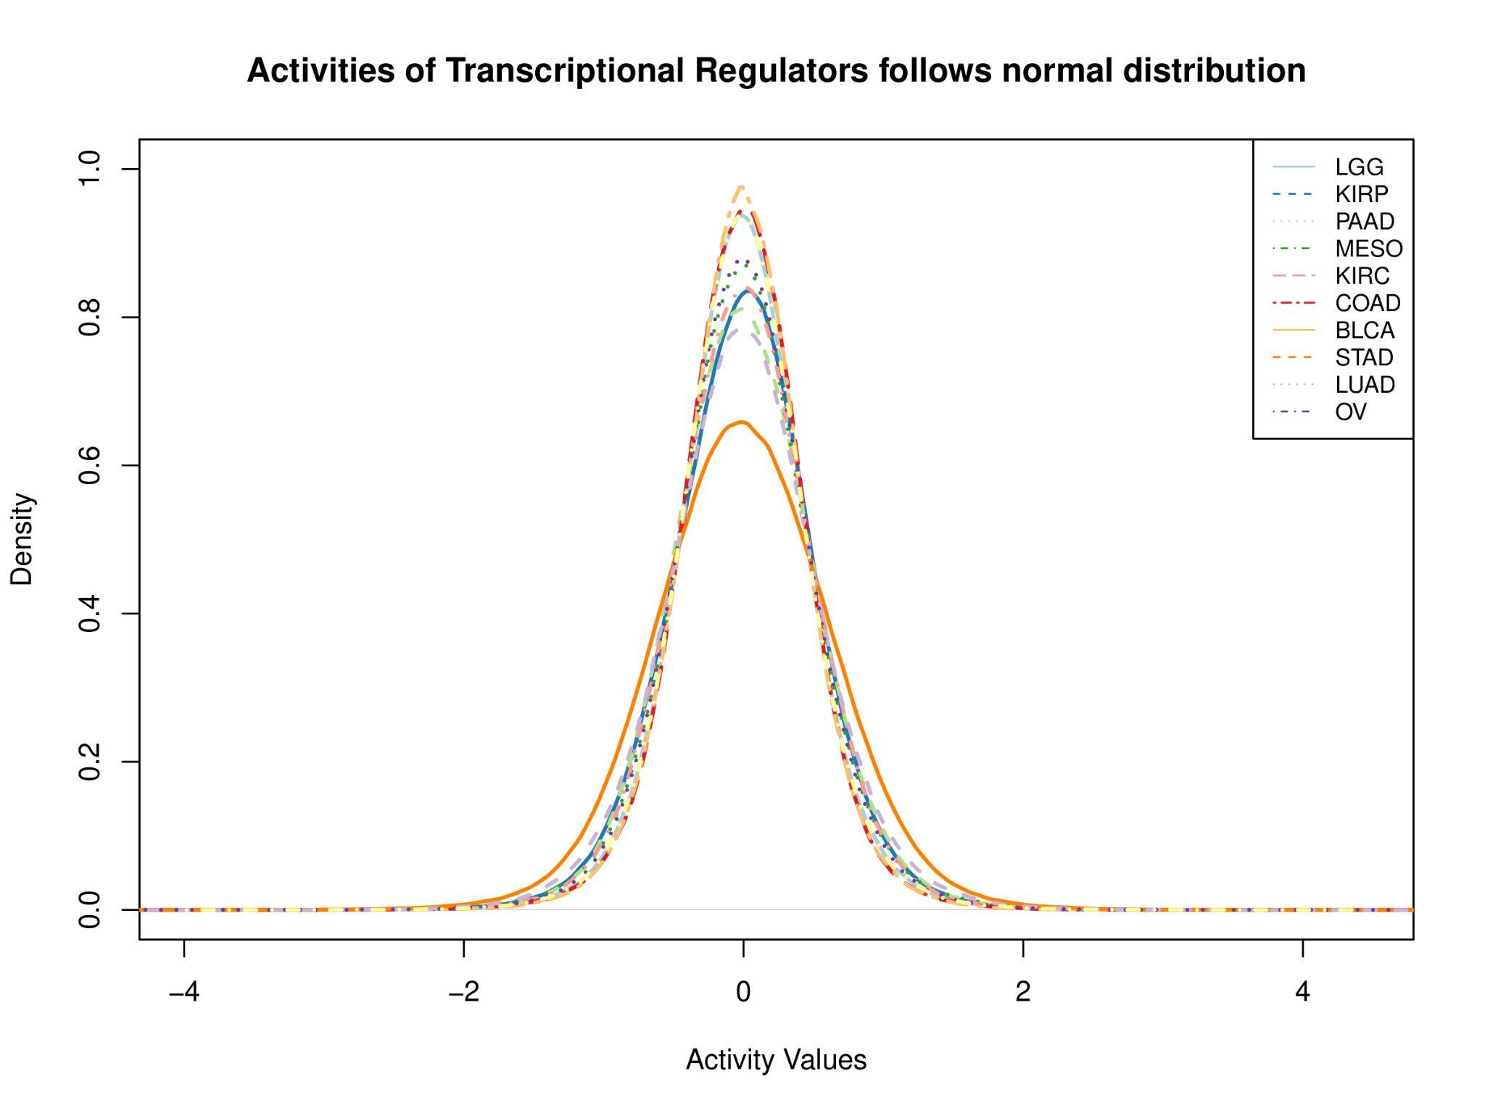

**Figure S3**: Activity profiles of transcriptional regulators follow a normal distribution for a particular cancer.

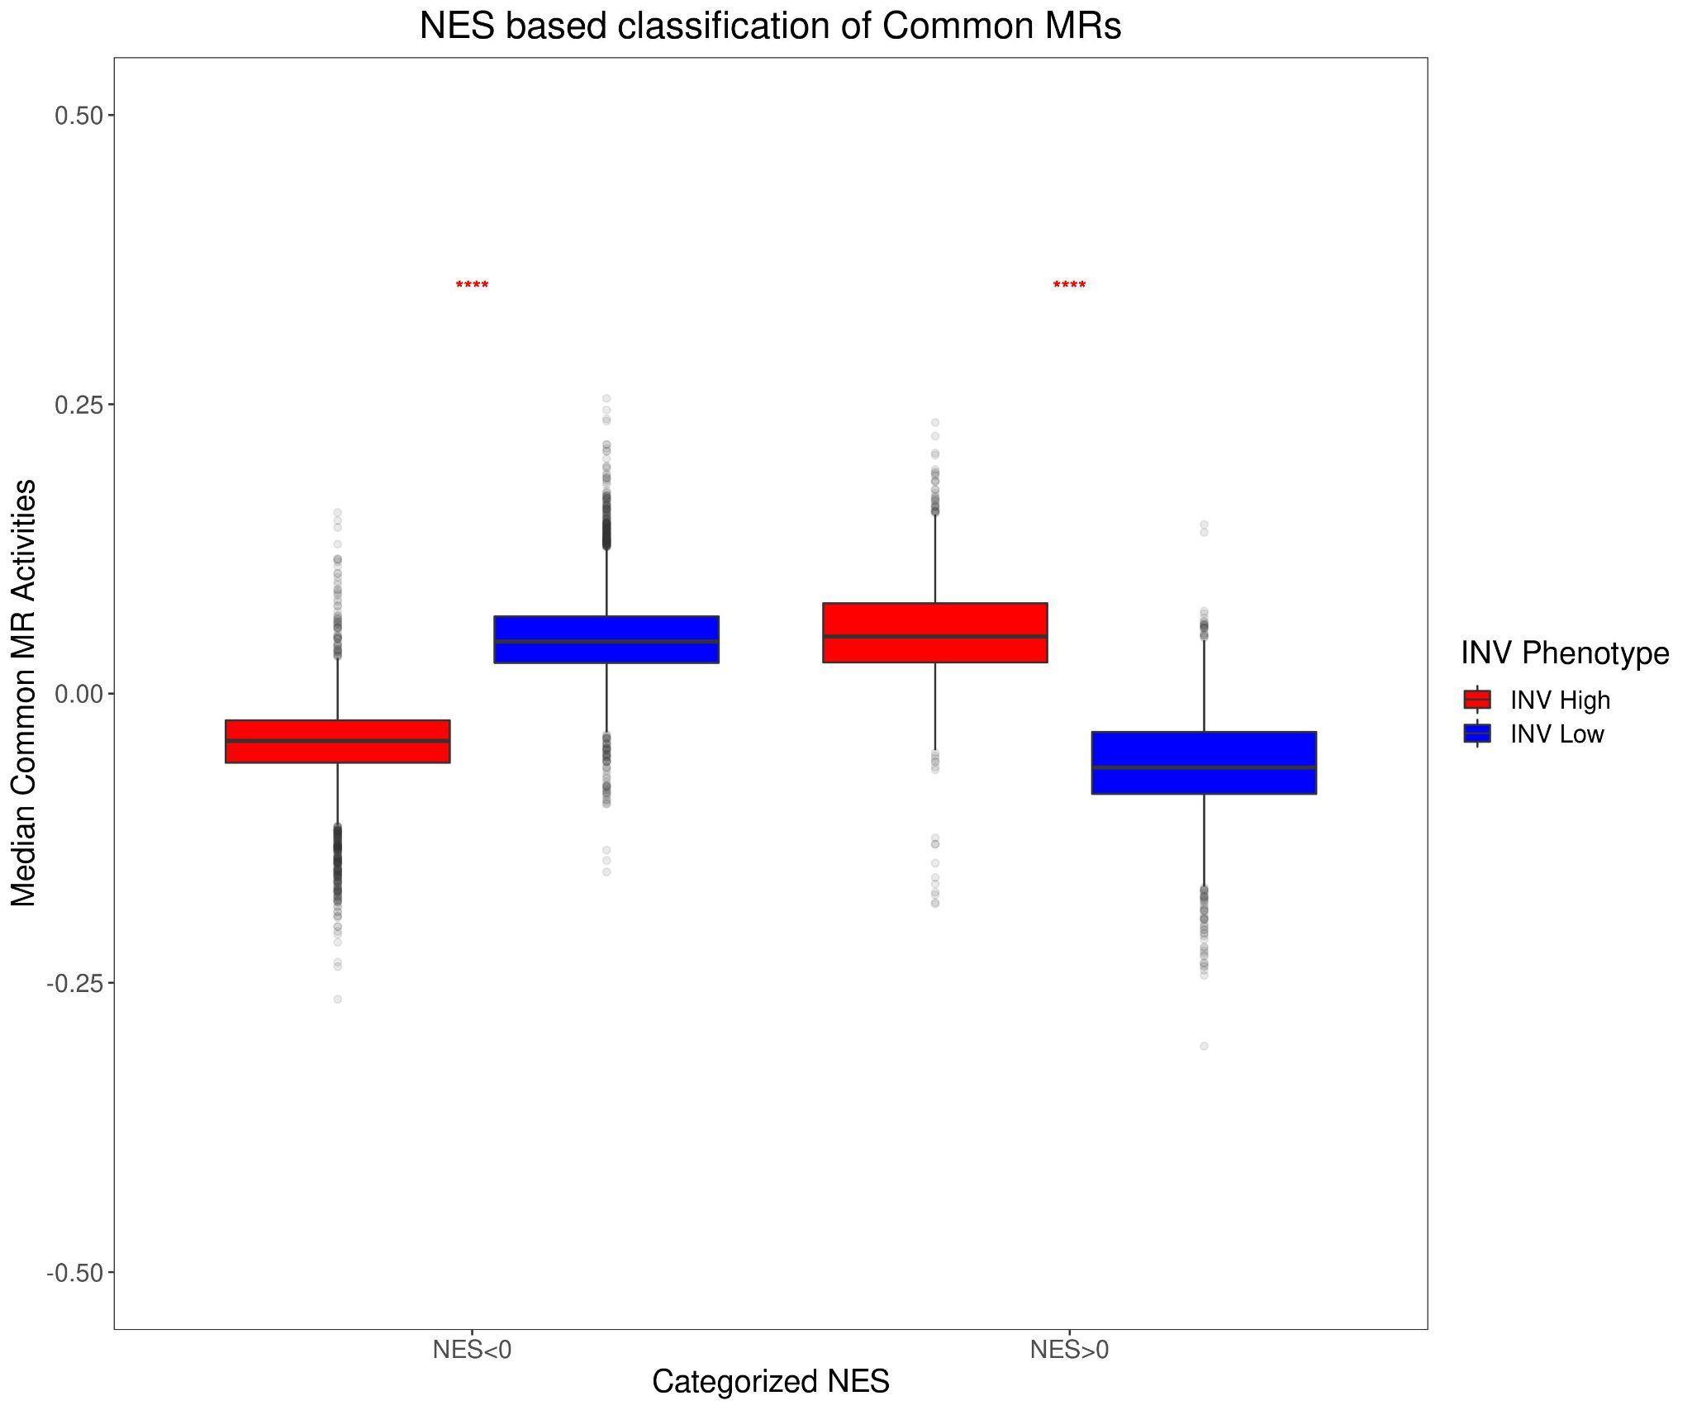

**Figure S4**: Here we highlight that when the normalized enrichment scores (NES) for TRs are positive then, these TRs have high positive activity in INV-H samples and high negative activity in INV-L samples. Thus, TRs with positive NES scores are more specific to the INV-H phenotype. Similarly, when the NES are negative for TRs then, these TRs have high positive activity in INV-L samples and high negative activity in INV-H samples. Thus, TRs with negative NES are

more specific to the INV-L phenotype (p-value < 1e-5).

| **MR** | **Statistic** | **P-value** | **Mean INV-H** | **Mean INV-L** | **Mean FC** | **P-adjust** |
| --- | --- | --- | --- | --- | --- | --- |
| COL1A1 | 100 | 0.00018 | 0.069 | -0.081 | 0.15 | 0.00037 |
| SERPINE1 | 100 | 0.00018 | 0.066 | -0.079 | 0.144 | 0.00037 |
| LUM | 100 | 0.00018 | 0.068 | -0.069 | 0.136 | 0.00037 |
| SFRP2 | 92 | 0.00171 | 0.058 | -0.074 | 0.131 | 0.00171 |
| ENG | 96 | 0.00058 | 0.056 | -0.052 | 0.108 | 0.0007 |
| BCL6B | 99 | 0.00025 | 0.051 | -0.048 | 0.1 | 0.00037 |

**Table S1:** MRs common across all the 10 cancer types of interest and specific to INV-H phenotype (Mean FC > 0).

| **MR** | **Prognostic Cancer Subtypes** | **Total Cancer Subtypes** |
| --- | --- | --- |
| SPI1 | LGG KIRP PAAD KIRC COAD BLCA STAD LUAD OV | 9 |
| ITGB2 | LGG KIRP PAAD KIRC COAD BLCA STAD LUAD OV | 9 |
| DCN | LGG KIRP PAAD KIRC COAD BLCA STAD LUAD OV | 9 |
| TFEC | LGG KIRP PAAD KIRC COAD BLCA STAD LUAD OV | 9 |
| CD4 | LGG KIRP PAAD KIRC COAD BLCA STAD LUAD OV | 9 |
| TNFSF8 | LGG KIRP PAAD KIRC COAD BLCA STAD LUAD OV | 9 |
| CD86 | LGG KIRP PAAD KIRC COAD BLCA STAD LUAD OV | 9 |
| HCK | LGG KIRP PAAD KIRC COAD BLCA STAD LUAD OV | 9 |
| PLEK | LGG KIRP PAAD KIRC COAD BLCA STAD LUAD OV | 9 |
| NFAM1 | LGG KIRP PAAD KIRC COAD BLCA STAD LUAD OV | 9 |
| SFRP4 | LGG KIRP PAAD MESO COAD BLCA STAD LUAD OV | 9 |
| IL6 | LGG KIRP PAAD KIRC COAD BLCA STAD LUAD OV | 9 |
| HSF4 | LGG KIRP PAAD MESO KIRC COAD BLCA STAD LUAD | 9 |
| TRIM52 | LGG KIRP PAAD MESO KIRC COAD BLCA STAD LUAD | 9 |
| CDH13 | LGG KIRP PAAD MESO KIRC COAD STAD LUAD OV | 9 |
| TGFB1 | LGG KIRP PAAD MESO KIRC COAD STAD LUAD OV | 9 |
| PRRX1 | KIRP PAAD MESO KIRC COAD BLCA STAD LUAD OV | 9 |
| GREM1 | KIRP PAAD MESO KIRC COAD BLCA STAD LUAD OV | 9 |
| TGFB1I1 | KIRP PAAD MESO KIRC COAD BLCA STAD LUAD OV | 9 |
| MEIS3 | KIRP PAAD MESO KIRC COAD BLCA STAD LUAD OV | 9 |
| CAVIN1 | LGG PAAD KIRC COAD BLCA STAD LUAD OV | 8 |
| LILRB4 | LGG PAAD KIRC COAD BLCA STAD LUAD OV | 8 |
| MECOM | LGG KIRP MESO KIRC COAD BLCA STAD LUAD | 8 |
| NLRP3 | LGG PAAD KIRC COAD BLCA STAD LUAD OV | 8 |
| TMIGD3 | LGG PAAD KIRC COAD BLCA STAD LUAD OV | 8 |
| CXCL10 | LGG KIRP PAAD COAD BLCA STAD LUAD OV | 8 |
| FLI1 | LGG KIRP PAAD KIRC COAD BLCA STAD OV | 8 |
| DAB2 | LGG PAAD KIRC COAD BLCA STAD LUAD OV | 8 |
| RHOH | LGG KIRP PAAD KIRC COAD BLCA LUAD OV | 8 |
| VGLL3 | LGG KIRP PAAD KIRC COAD STAD LUAD OV | 8 |
| ZNF785 | LGG KIRP PAAD MESO KIRC BLCA STAD LUAD | 8 |
| BOLA1 | LGG KIRP PAAD MESO KIRC COAD BLCA STAD | 8 |
| ZNF692 | LGG KIRP KIRC COAD BLCA STAD LUAD OV | 8 |
| CARF | LGG KIRP KIRC COAD BLCA STAD LUAD OV | 8 |
| MED11 | LGG KIRP PAAD MESO KIRC COAD BLCA LUAD | 8 |
| SMO | LGG KIRP PAAD COAD BLCA STAD LUAD OV | 8 |
| SARNP | LGG KIRP PAAD KIRC COAD BLCA STAD LUAD | 8 |
| MZF1 | LGG KIRP PAAD KIRC COAD BLCA STAD LUAD | 8 |
| HOPX | LGG KIRP PAAD KIRC COAD STAD LUAD OV | 8 |
| ERG | KIRP MESO KIRC COAD BLCA STAD LUAD OV | 8 |
| ZNF789 | KIRP PAAD KIRC COAD BLCA STAD LUAD OV | 8 |
| SULF1 | KIRP PAAD KIRC COAD BLCA STAD LUAD OV | 8 |
| GTF2IRD2 | KIRP PAAD KIRC COAD BLCA STAD LUAD OV | 8 |
| ZNF862 | KIRP PAAD KIRC COAD BLCA STAD LUAD OV | 8 |
| CYR61 | KIRP PAAD MESO COAD BLCA STAD LUAD OV | 8 |
| GTF2IRD2B | KIRP PAAD KIRC COAD BLCA STAD LUAD OV | 8 |
| ZNF469 | PAAD MESO KIRC COAD BLCA STAD LUAD OV | 8 |
| LZTS1 | PAAD MESO KIRC COAD BLCA STAD LUAD OV | 8 |
| ACTN1 | LGG PAAD MESO KIRC BLCA STAD LUAD | 7 |
| TGFB2 | LGG KIRP PAAD MESO KIRC BLCA STAD | 7 |
| CAV1 | LGG KIRP PAAD COAD BLCA STAD OV | 7 |
| FANK1 | LGG KIRP MESO KIRC COAD LUAD OV | 7 |
| HAVCR2 | LGG PAAD COAD BLCA STAD LUAD OV | 7 |
| ACVRL1 | LGG PAAD MESO KIRC BLCA STAD OV | 7 |
| IKZF1 | LGG KIRP PAAD KIRC COAD BLCA OV | 7 |
| DEPDC1 | LGG KIRP MESO KIRC COAD STAD LUAD | 7 |
| SLC11A1 | LGG PAAD COAD BLCA STAD LUAD OV | 7 |
| CENPF | LGG KIRP MESO KIRC COAD STAD LUAD | 7 |
| FOXM1 | LGG KIRP MESO KIRC COAD STAD LUAD | 7 |
| BIRC5 | LGG KIRP MESO KIRC COAD STAD LUAD | 7 |
| TOP2A | LGG KIRP MESO KIRC COAD STAD LUAD | 7 |
| CD3D | LGG KIRP PAAD KIRC COAD BLCA OV | 7 |
| IL16 | LGG KIRP PAAD KIRC COAD BLCA OV | 7 |
| FOSL1 | LGG KIRP PAAD KIRC BLCA LUAD OV | 7 |
| ICAM1 | LGG PAAD KIRC COAD BLCA STAD OV | 7 |
| MNDA | LGG KIRP PAAD COAD BLCA STAD OV | 7 |
| TSSK4 | LGG KIRP KIRC COAD BLCA STAD LUAD | 7 |
| APBB3 | LGG KIRP KIRC COAD BLCA STAD LUAD | 7 |
| ZEB2 | LGG PAAD COAD BLCA STAD LUAD OV | 7 |
| ZNF337 | LGG KIRP KIRC COAD BLCA STAD LUAD | 7 |
| HDAC10 | LGG PAAD KIRC COAD BLCA STAD LUAD | 7 |
| ZNF23 | LGG KIRP KIRC COAD BLCA STAD LUAD | 7 |
| S1PR1 | LGG KIRP MESO COAD BLCA STAD OV | 7 |
| ZNF276 | LGG KIRP KIRC COAD BLCA STAD LUAD | 7 |
| ZC3H8 | LGG KIRP PAAD KIRC COAD STAD LUAD | 7 |
| STK36 | LGG KIRP KIRC COAD BLCA LUAD OV | 7 |
| GLI4 | LGG KIRP MESO KIRC COAD BLCA LUAD | 7 |
| MYOCD | LGG KIRP KIRC COAD BLCA STAD OV | 7 |
| ZNF169 | LGG KIRP KIRC COAD BLCA STAD LUAD | 7 |
| ZNF354B | LGG KIRP KIRC COAD BLCA STAD LUAD | 7 |
| ZNF688 | LGG KIRP PAAD MESO KIRC COAD BLCA | 7 |
| ZRANB2 | LGG KIRP COAD BLCA STAD LUAD OV | 7 |
| LHX4 | LGG KIRP KIRC COAD BLCA STAD LUAD | 7 |
| NOTCH3 | KIRP PAAD MESO KIRC COAD STAD LUAD | 7 |
| AGER | KIRP KIRC COAD BLCA STAD LUAD OV | 7 |
| RBM39 | KIRP KIRC COAD BLCA STAD LUAD OV | 7 |
| TAF1C | KIRP KIRC COAD BLCA STAD LUAD OV | 7 |
| LPIN3 | KIRP MESO KIRC COAD BLCA STAD LUAD | 7 |
| SOX18 | KIRP MESO KIRC COAD BLCA STAD LUAD | 7 |
| OSM | KIRP PAAD KIRC COAD BLCA STAD OV | 7 |
| ALKBH4 | KIRP PAAD KIRC COAD BLCA STAD OV | 7 |
| ZNF19 | KIRP PAAD KIRC COAD BLCA LUAD OV | 7 |
| MRPL12 | KIRP PAAD MESO KIRC COAD BLCA STAD | 7 |
| KANK2 | PAAD MESO KIRC COAD BLCA STAD LUAD | 7 |
| MEF2C | PAAD MESO KIRC COAD BLCA STAD OV | 7 |
| ZEB1 | PAAD KIRC COAD BLCA STAD LUAD OV | 7 |
| DKK3 | PAAD MESO KIRC COAD BLCA STAD LUAD | 7 |
| MSC | PAAD KIRC COAD BLCA STAD LUAD OV | 7 |
| FLNA | LGG PAAD KIRC COAD BLCA STAD | 6 |
| CCNL2 | LGG KIRP COAD BLCA STAD LUAD | 6 |
| TCEA3 | LGG KIRP PAAD KIRC COAD LUAD | 6 |
| ITGA3 | LGG KIRP PAAD KIRC LUAD OV | 6 |
| NCF1 | LGG PAAD COAD BLCA LUAD OV | 6 |
| CD74 | LGG KIRP PAAD COAD BLCA OV | 6 |
| LYL1 | LGG KIRP KIRC BLCA STAD OV | 6 |
| CDC45 | LGG MESO KIRC COAD STAD LUAD | 6 |
| CCNA2 | LGG MESO KIRC COAD STAD LUAD | 6 |
| DLGAP5 | LGG MESO KIRC COAD STAD LUAD | 6 |
| CD28 | LGG PAAD KIRC COAD BLCA OV | 6 |
| AURKB | LGG MESO KIRC COAD STAD LUAD | 6 |
| TLR2 | LGG PAAD KIRC COAD STAD OV | 6 |
| PYHIN1 | LGG KIRP PAAD COAD BLCA OV | 6 |
| PSMB9 | LGG PAAD COAD BLCA LUAD OV | 6 |
| EOMES | LGG KIRP PAAD COAD BLCA OV | 6 |
| S100A9 | LGG KIRP PAAD COAD BLCA LUAD | 6 |
| PLK1 | LGG MESO KIRC COAD STAD LUAD | 6 |
| ATP8B1 | LGG MESO KIRC BLCA STAD LUAD | 6 |
| L3MBTL1 | LGG KIRP KIRC BLCA LUAD OV | 6 |
| DDX17 | LGG KIRP KIRC BLCA STAD LUAD | 6 |
| CENPT | LGG KIRP KIRC COAD BLCA LUAD | 6 |
| APBB1 | LGG KIRP KIRC COAD BLCA STAD | 6 |
| KAT2A | LGG KIRP KIRC COAD BLCA LUAD | 6 |
| ZNF133 | LGG KIRP PAAD BLCA STAD LUAD | 6 |
| PDE2A | LGG KIRP COAD BLCA STAD LUAD | 6 |
| NOTCH4 | LGG KIRP MESO COAD STAD OV | 6 |
| FOXC2 | LGG KIRP MESO KIRC BLCA OV | 6 |
| GATAD1 | LGG KIRP MESO KIRC COAD LUAD | 6 |
| FBXL15 | LGG KIRP PAAD KIRC COAD LUAD | 6 |
| MXD3 | LGG KIRP COAD BLCA STAD LUAD | 6 |
| TNFAIP3 | LGG KIRP PAAD BLCA LUAD OV | 6 |
| CDK11A | LGG KIRP COAD BLCA STAD LUAD | 6 |
| HMGA2 | LGG PAAD KIRC BLCA LUAD OV | 6 |
| MSRB2 | LGG KIRP MESO KIRC COAD LUAD | 6 |
| APOE | LGG PAAD KIRC COAD BLCA STAD | 6 |
| TAF1D | LGG COAD BLCA STAD LUAD OV | 6 |
| SAP18 | LGG KIRP PAAD KIRC COAD LUAD | 6 |
| PTGES2 | LGG KIRP PAAD KIRC COAD STAD | 6 |
| DMTF1 | KIRP KIRC COAD BLCA STAD LUAD | 6 |
| DDX39B | KIRP KIRC COAD BLCA STAD LUAD | 6 |
| PABPC1L | KIRP COAD BLCA STAD LUAD OV | 6 |
| CDK5RAP3 | KIRP KIRC COAD BLCA STAD LUAD | 6 |
| CMKLR1 | KIRP KIRC COAD BLCA STAD OV | 6 |
| PNN | KIRP COAD BLCA STAD LUAD OV | 6 |
| POU2AF1 | KIRP PAAD KIRC COAD BLCA LUAD | 6 |
| ANKRD49 | KIRP PAAD KIRC COAD BLCA STAD | 6 |
| SOX17 | KIRP MESO KIRC COAD BLCA STAD | 6 |
| PAXBP1 | KIRP KIRC COAD BLCA STAD LUAD | 6 |
| EFCAB6 | KIRP PAAD MESO KIRC LUAD OV | 6 |
| RECQL5 | KIRP KIRC COAD BLCA STAD LUAD | 6 |
| ELP6 | KIRP PAAD COAD BLCA STAD LUAD | 6 |
| MED31 | KIRP PAAD MESO COAD BLCA LUAD | 6 |
| TLR4 | KIRP PAAD KIRC STAD LUAD OV | 6 |
| SLIRP | KIRP PAAD KIRC COAD BLCA STAD | 6 |
| BNC2 | PAAD COAD BLCA STAD LUAD OV | 6 |
| HAND2 | PAAD KIRC COAD BLCA STAD OV | 6 |
| ZNF423 | PAAD KIRC COAD STAD LUAD OV | 6 |
| PIDD1 | PAAD KIRC COAD STAD LUAD OV | 6 |

**Table S2**: List of master regulators (differentially activated TRs) common across 6 or more prognostic cancer subtypes. We showcase the cancers for which these MRs are differentially active.

| **MR** | **Median FC** | **FDR-adjusted P-value** |
| --- | --- | --- |
| PRRX1 | 0.14 | 3.59088E-199 |
| SFRP4 | 0.13 | 2.11824E-164 |
| IL6 | 0.129 | 1.2632E-187 |
| SULF1 | 0.126 | 1.89773E-186 |
| GREM1 | 0.124 | 1.92755E-175 |
| ACTN1 | 0.119 | 2.27279E-178 |
| HAND2 | 0.117 | 5.80894E-94 |
| CYR61 | 0.116 | 1.56904E-114 |
| CAV1 | 0.114 | 2.78075E-144 |
| CD4 | 0.113 | 1.99725E-146 |
| DCN | 0.113 | 5.9343E-140 |
| TGFB1 | 0.113 | 3.09548E-151 |
| TGFB1I1 | 0.112 | 3.61244E-173 |
| TNFAIP3 | 0.111 | 2.54043E-129 |
| ICAM1 | 0.108 | 3.30611E-143 |
| ITGB2 | 0.108 | 3.2079E-136 |
| IKZF1 | 0.106 | 2.04186E-130 |
| PLEK | 0.106 | 2.94464E-134 |
| FLI1 | 0.105 | 3.92372E-133 |
| FLNA | 0.105 | 2.7219E-155 |
| ZNF469 | 0.103 | 8.61599E-140 |
| RHOH | 0.102 | 1.19118E-131 |
| IL16 | 0.1 | 1.90517E-115 |
| NFAM1 | 0.1 | 6.27254E-110 |
| VGLL3 | 0.1 | 3.19178E-123 |
| SPI1 | 0.099 | 1.27432E-116 |
| HCK | 0.098 | 2.04889E-125 |
| OSM | 0.098 | 8.30795E-137 |
| CAVIN1 | 0.096 | 1.90517E-115 |
| LZTS1 | 0.096 | 8.24837E-119 |
| LILRB4 | 0.095 | 6.38461E-129 |
| MNDA | 0.094 | 8.94768E-118 |
| CD28 | 0.093 | 1.65997E-89 |
| KANK2 | 0.093 | 5.6825E-66 |
| CD86 | 0.092 | 6.51811E-111 |
| APOE | 0.09 | 1.66803E-111 |
| CMKLR1 | 0.089 | 2.22728E-90 |
| HOPX | 0.089 | 3.43635E-77 |
| MEIS3 | 0.088 | 2.10216E-121 |
| ZEB2 | 0.088 | 9.04445E-105 |
| PYHIN1 | 0.087 | 1.99051E-92 |
| TMIGD3 | 0.087 | 3.16117E-97 |
| MSC | 0.086 | 5.71549E-107 |
| TGFB2 | 0.086 | 1.10253E-83 |
| CD3D | 0.085 | 2.05457E-96 |
| SLC11A1 | 0.084 | 1.85649E-114 |
| LYL1 | 0.083 | 6.10771E-74 |
| NCF1 | 0.083 | 1.11961E-101 |
| BNC2 | 0.082 | 2.37692E-104 |
| TNFSF8 | 0.082 | 3.26604E-93 |
| SOX18 | 0.081 | 1.07978E-80 |
| FOSL1 | 0.079 | 2.31673E-109 |
| MEF2C | 0.079 | 2.4913E-70 |
| TLR4 | 0.079 | 5.35989E-96 |
| S1PR1 | 0.078 | 1.70724E-77 |
| CDH13 | 0.076 | 1.93291E-76 |
| FOXC2 | 0.076 | 7.06834E-60 |
| NOTCH3 | 0.075 | 1.33169E-64 |
| EOMES | 0.074 | 1.05653E-83 |
| TLR2 | 0.073 | 2.59306E-79 |
| ZEB1 | 0.072 | 5.2941E-60 |
| DKK3 | 0.071 | 1.26873E-57 |
| NLRP3 | 0.071 | 9.61725E-98 |
| ACVRL1 | 0.069 | 3.05705E-73 |
| HAVCR2 | 0.069 | 1.59516E-69 |
| ERG | 0.068 | 1.32955E-61 |
| S100A9 | 0.067 | 3.68347E-87 |
| TFEC | 0.066 | 2.67477E-55 |
| POU2AF1 | 0.064 | 1.85099E-66 |
| SMO | 0.06 | 1.81987E-52 |
| CXCL10 | 0.056 | 4.04738E-59 |
| HMGA2 | 0.055 | 1.61796E-35 |
| CD74 | 0.053 | 1.59335E-38 |
| ITGA3 | 0.052 | 9.7305E-62 |
| SOX17 | 0.05 | 6.52188E-31 |
| MYOCD | 0.048 | 5.55969E-24 |
| DAB2 | 0.046 | 8.55049E-34 |
| NOTCH4 | 0.046 | 1.77407E-39 |
| PDE2A | 0.045 | 5.84218E-24 |
| PSMB9 | 0.043 | 1.35109E-33 |
| CCNA2 | 0.041 | 1.66133E-22 |
| DLGAP5 | 0.04 | 3.21625E-20 |
| DEPDC1 | 0.034 | 3.70209E-15 |
| CENPF | 0.033 | 3.7646E-18 |
| PLK1 | 0.033 | 2.832E-17 |
| BIRC5 | 0.026 | 1.05808E-12 |
| FOXM1 | 0.026 | 3.47683E-13 |
| AURKB | 0.025 | 5.02519E-12 |
| CDC45 | 0.017 | 7.26553E-05 |
| APBB1 | 0.011 | 0.00107077 |
| TOP2A | 0.011 | 0.0427786 |
| ATP8B1 | -0.012 | 7.65375E-05 |
| MECOM | -0.028 | 3.49912E-20 |
| SLIRP | -0.029 | 5.2527E-20 |
| MRPL12 | -0.03 | 1.9839E-14 |
| SAP18 | -0.031 | 1.08252E-17 |
| ZNF862 | -0.031 | 7.7636E-15 |
| MSRB2 | -0.035 | 2.14344E-11 |
| DMTF1 | -0.041 | 6.47611E-39 |
| MXD3 | -0.044 | 3.12443E-21 |
| MED31 | -0.047 | 5.68006E-29 |
| CCNL2 | -0.05 | 2.79861E-37 |
| ZNF688 | -0.05 | 1.54615E-43 |
| ALKBH4 | -0.051 | 1.16661E-39 |
| PTGES2 | -0.051 | 1.20333E-34 |
| GATAD1 | -0.052 | 2.93727E-39 |
| ZRANB2 | -0.054 | 3.79038E-49 |
| CENPT | -0.056 | 6.76405E-54 |
| DDX17 | -0.056 | 1.88148E-55 |
| ELP6 | -0.057 | 4.09106E-53 |
| TAF1D | -0.058 | 4.14829E-56 |
| ZNF789 | -0.058 | 8.23431E-54 |
| RBM39 | -0.059 | 5.27432E-51 |
| ZNF354B | -0.059 | 3.37682E-55 |
| LPIN3 | -0.06 | 9.20356E-47 |
| PABPC1L | -0.06 | 3.0138E-57 |
| TCEA3 | -0.06 | 1.69945E-44 |
| RECQL5 | -0.061 | 6.17828E-61 |
| STK36 | -0.063 | 2.19279E-65 |
| ZNF337 | -0.063 | 5.49267E-75 |
| TSSK4 | -0.064 | 2.05381E-88 |
| DDX39B | -0.065 | 1.16542E-74 |
| MED11 | -0.065 | 1.04371E-89 |
| BOLA1 | -0.066 | 2.41146E-58 |
| PNN | -0.066 | 2.91248E-72 |
| HDAC10 | -0.067 | 3.68689E-73 |
| PAXBP1 | -0.067 | 2.09283E-68 |
| FBXL15 | -0.068 | 1.49787E-91 |
| PIDD1 | -0.068 | 6.25217E-52 |
| GLI4 | -0.071 | 3.03959E-67 |
| ZNF276 | -0.071 | 7.98378E-85 |
| MZF1 | -0.072 | 2.88872E-80 |
| CDK11A | -0.073 | 2.67798E-52 |
| CDK5RAP3 | -0.073 | 2.31819E-90 |
| ANKRD49 | -0.074 | 9.32838E-67 |
| FANK1 | -0.074 | 2.01155E-67 |
| SARNP | -0.074 | 2.83815E-71 |
| TAF1C | -0.074 | 3.05395E-87 |
| ZNF133 | -0.075 | 7.66943E-69 |
| ZNF785 | -0.075 | 3.95633E-88 |
| APBB3 | -0.076 | 2.29993E-113 |
| ZNF23 | -0.076 | 3.35178E-83 |
| ZC3H8 | -0.078 | 3.00048E-87 |
| CARF | -0.079 | 1.06663E-91 |
| HSF4 | -0.079 | 1.74883E-102 |
| KAT2A | -0.079 | 6.48096E-93 |
| ZNF692 | -0.08 | 2.43483E-91 |
| AGER | -0.084 | 5.25566E-126 |
| EFCAB6 | -0.084 | 1.94044E-97 |
| ZNF169 | -0.084 | 1.45339E-113 |
| GTF2IRD2 | -0.085 | 2.47093E-109 |
| LHX4 | -0.086 | 1.72031E-137 |
| TRIM52 | -0.087 | 3.36803E-112 |
| L3MBTL1 | -0.091 | 4.77603E-110 |
| GTF2IRD2B | -0.095 | 2.00736E-134 |
| ZNF19 | -0.112 | 1.27428E-144 |

**Table S3**: List of 156 significant MRs common across the majority of the prognostic cancers and are ranked based on fold change (FC) between activities in INV-H vs activities in INV-L samples across all the 10 cancers using Wilcoxon rank sum test.

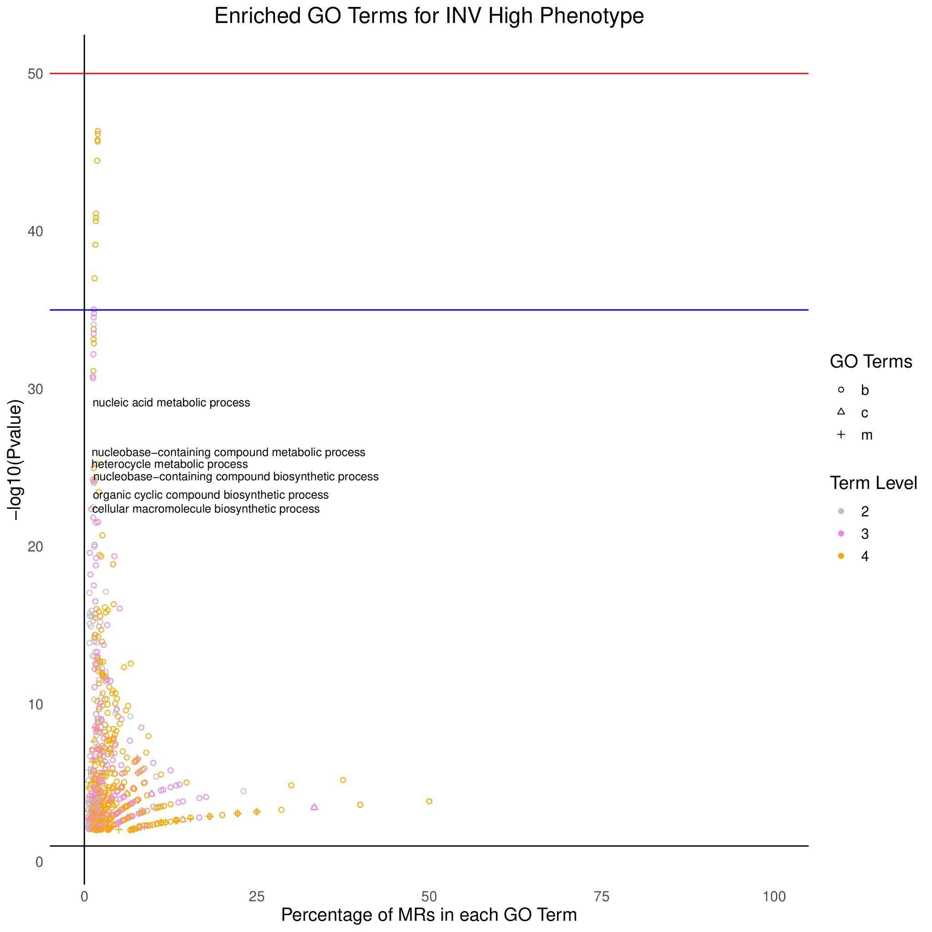

a) Most significant GO Terms associated with the common MRs specific to INV-H phenotype across 10 cancers. Here ‘b’ is for biological processes, ‘c’ is for cellular components, ‘m’ is for molecular functions.

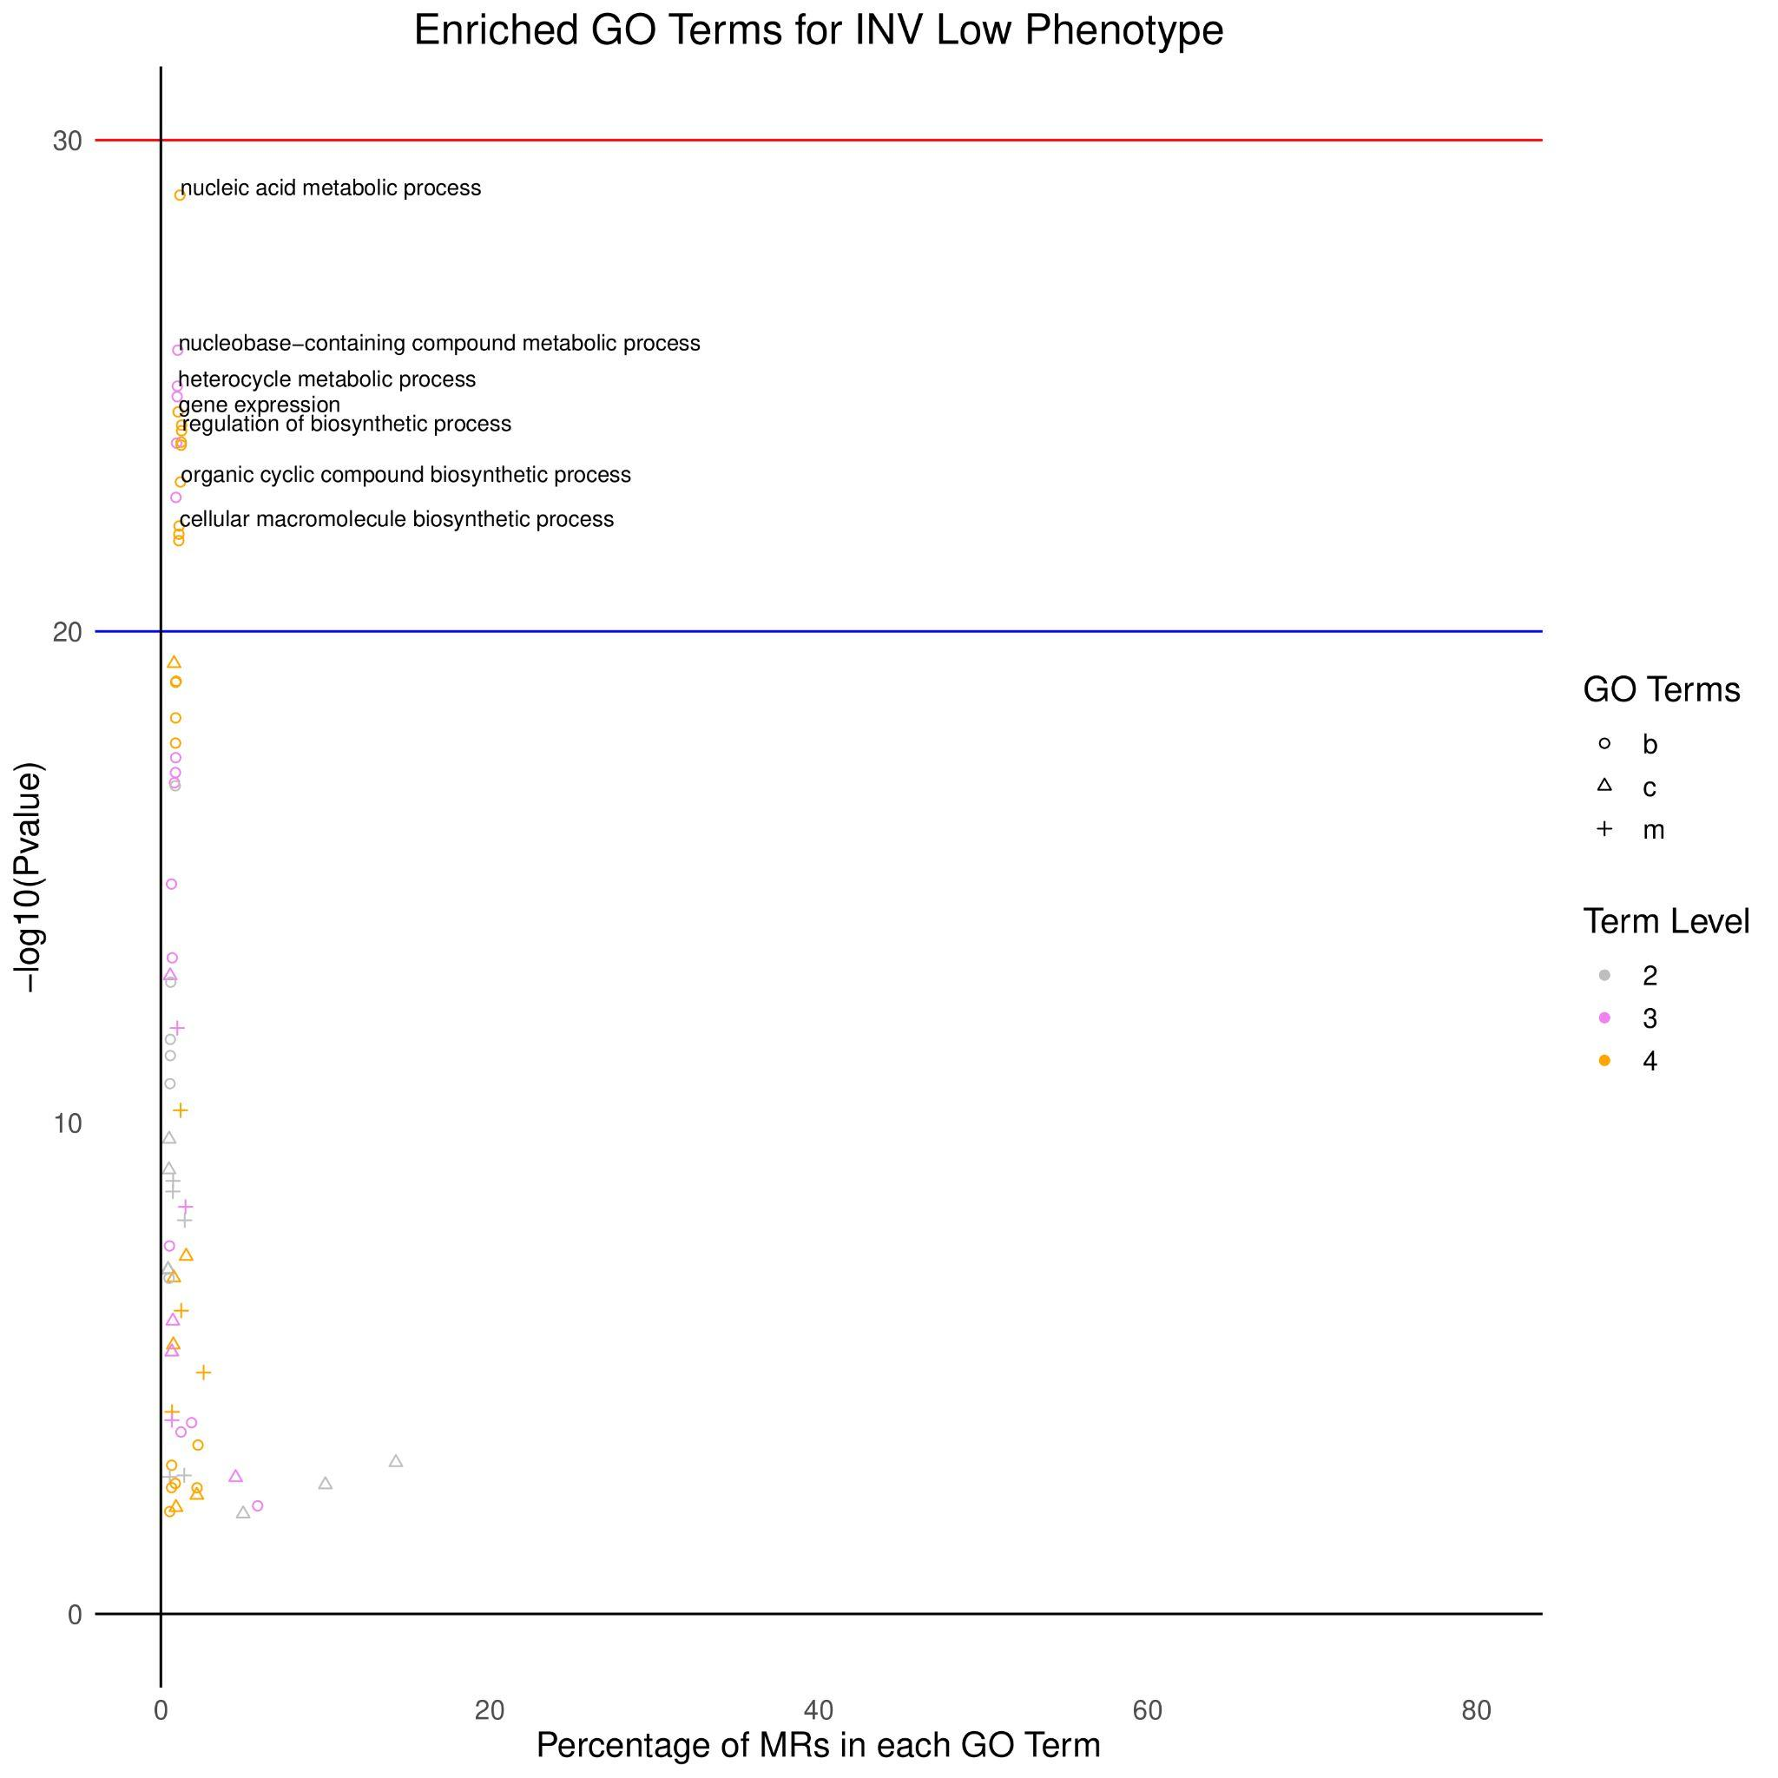

b) Most significant GO Terms associated with common MRs specific to INV-L phenotype across 10 cancers

**Figure S5:** GO Terms including Biological Processes (b), Cellular Components (c ), Molecular Functions (m) which are significantly enriched when performing over-expression analysis of common MRs for INV-H and INV-L phenotype respectively.

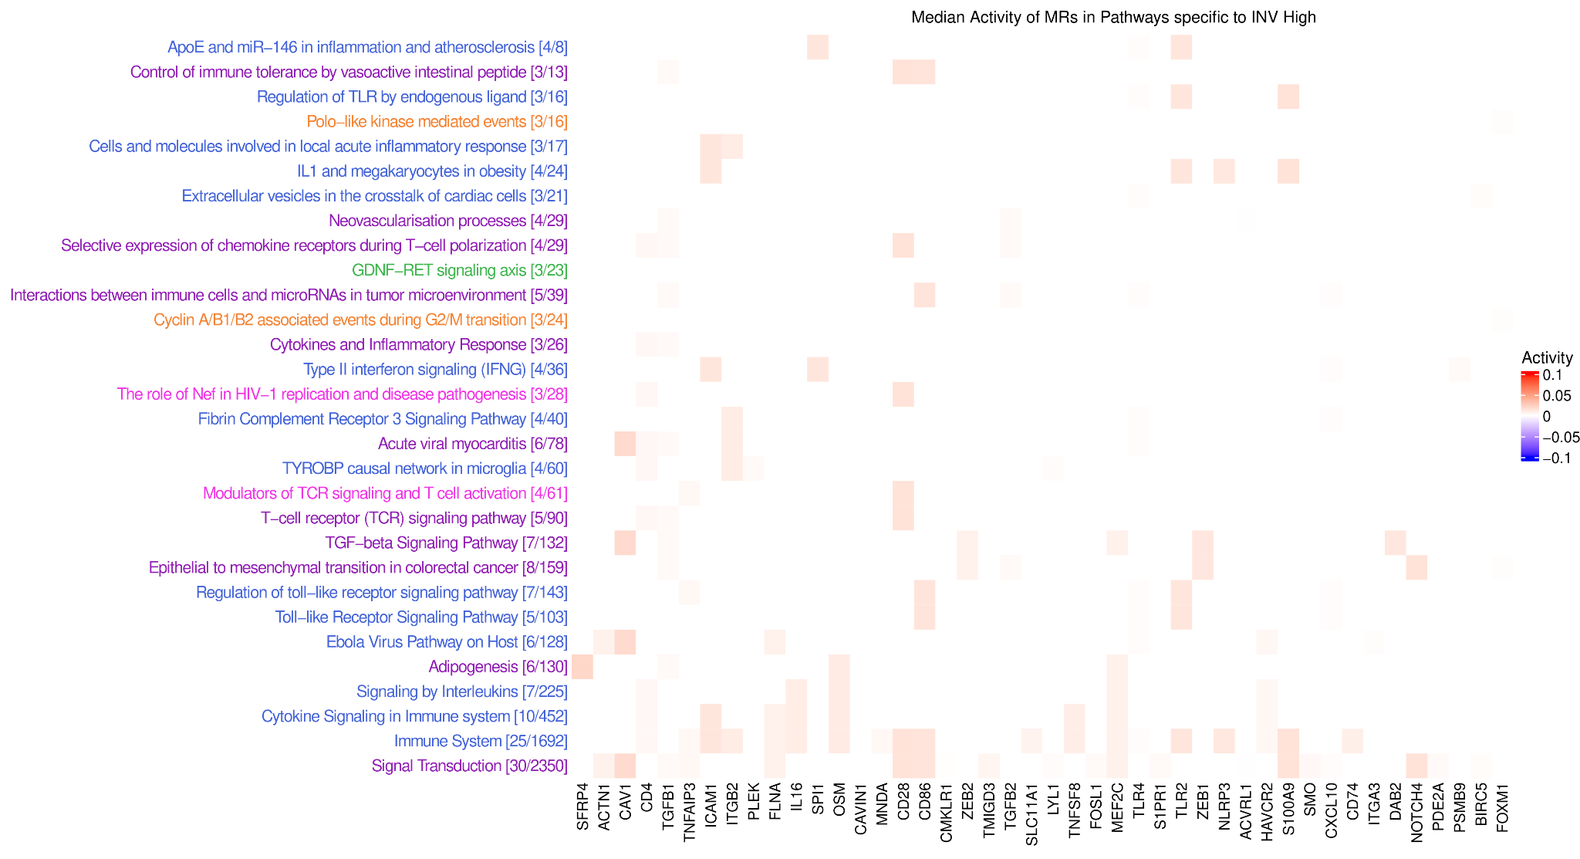

a) Heat plot showcasing the enriched pathways in which each of the top MRs are specific to INV High phenotype. The intensity represents the median activity of an MR across all the ten cancers of interest.

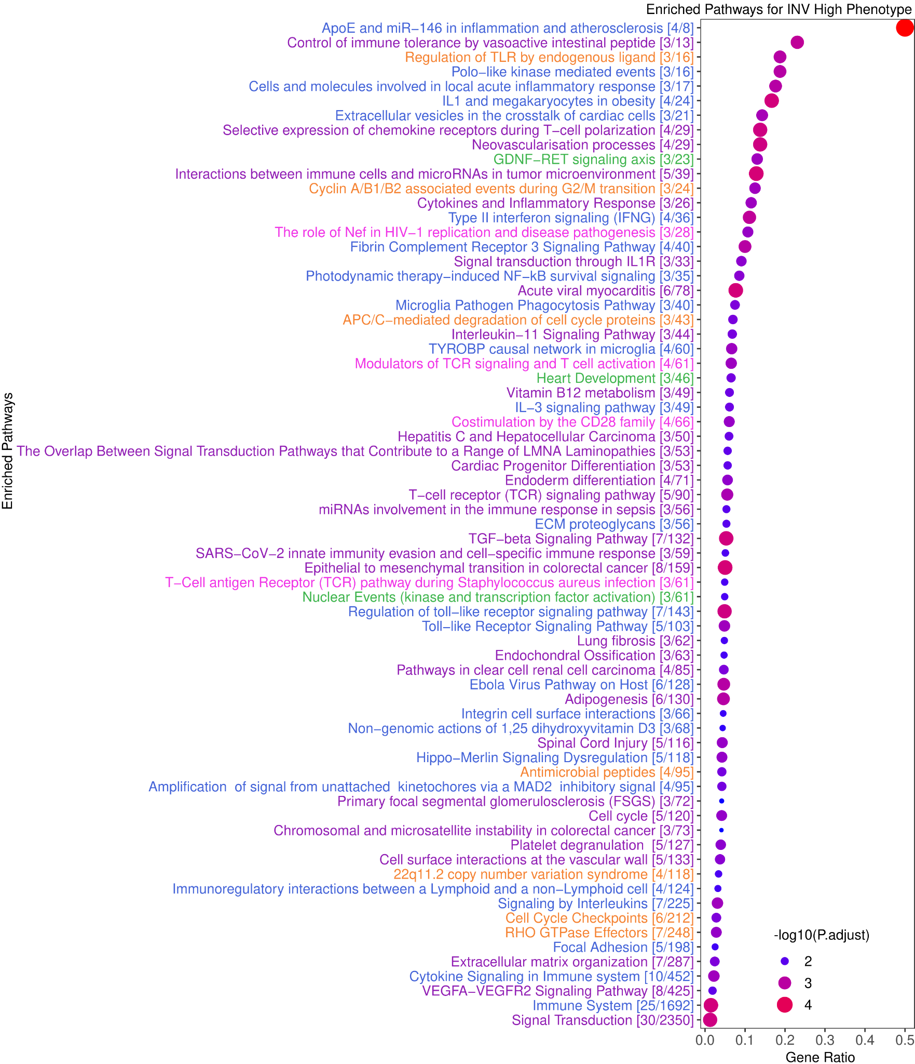

b) Dotplot showing the ratio between top MRs and the total number of genes in each enriched pathway, where the size of each dot is proportional to -log10(·) transformation on the adjusted p-values and the color of each dot increases from blue to red as p-values decrease. The enriched pathways are colored grounded on the cluster to which each pathway belongs based on overlap between the top MRs in the pathways.

**Figure S6:** The top enriched pathways obtained by over-expression analysis for the top MRs peculiar to INV High phenotype are highlighted here. The pathways are clustered and color-coded according to their respective clusters

| **MRs** | **P-value** | **Mean1** | **Mean2** | **FC Mean** | **P-adjust** |
| --- | --- | --- | --- | --- | --- |
| ZNF789 | 2.54E-207 | -0.049 | 0.049 | -0.098 | 6.6E-206 |
| ANKRD49 | 2.33E-168 | -0.049 | 0.045 | -0.094 | 3.63E-167 |
| BOLA1 | 1.77E-131 | -0.043 | 0.042 | -0.085 | 1.25E-130 |
| TRIM52 | 1.39E-127 | -0.039 | 0.045 | -0.084 | 7.76E-127 |
| ZNF692 | 2.97E-163 | -0.039 | 0.041 | -0.08 | 3.86E-162 |
| ELP6 | 6.47E-118 | -0.039 | 0.038 | -0.077 | 2.52E-117 |
| KAT2A | 1.87E-146 | -0.038 | 0.039 | -0.077 | 2.08E-145 |
| ALKBH4 | 8.46E-123 | -0.041 | 0.035 | -0.076 | 3.88E-122 |
| GLI4 | 8.34E-108 | -0.037 | 0.038 | -0.075 | 2.89E-107 |
| CDK5RAP3 | 4E-120 | -0.035 | 0.04 | -0.075 | 1.69E-119 |
| PAXBP1 | 7.98E-126 | -0.037 | 0.038 | -0.075 | 4.29E-125 |
| ZNF354B | 2.15E-138 | -0.04 | 0.035 | -0.075 | 1.77E-137 |
| HSF4 | 1.37E-139 | -0.036 | 0.039 | -0.075 | 1.19E-138 |
| HDAC10 | 1.1E-100 | -0.038 | 0.035 | -0.073 | 3.35E-100 |
| ZNF19 | 4.93E-112 | -0.038 | 0.035 | -0.073 | 1.79E-111 |
| RECQL5 | 7.96E-123 | -0.038 | 0.033 | -0.072 | 3.76E-122 |
| GTF2IRD2 | 2.31E-97 | -0.034 | 0.036 | -0.071 | 6.69E-97 |
| PTGES2 | 3.77E-93 | -0.035 | 0.033 | -0.069 | 1.03E-92 |
| ZC3H8 | 2.12E-85 | -0.033 | 0.034 | -0.067 | 5.08E-85 |
| ZNF169 | 5.03E-106 | -0.033 | 0.034 | -0.067 | 1.63E-105 |
| PIDD1 | 1.65E-87 | -0.032 | 0.034 | -0.066 | 4.08E-87 |
| CDK11A | 7.75E-79 | -0.036 | 0.026 | -0.062 | 1.63E-78 |
| ZNF23 | 1.2E-72 | -0.033 | 0.028 | -0.06 | 2.29E-72 |
| MXD3 | 3.28E-73 | -0.03 | 0.03 | -0.06 | 6.4E-73 |
| ZNF133 | 5.34E-78 | -0.033 | 0.026 | -0.059 | 1.1E-77 |
| ZNF337 | 2E-83 | -0.027 | 0.032 | -0.059 | 4.67E-83 |
| PABPC1L | 1.19E-86 | -0.028 | 0.029 | -0.058 | 2.9E-86 |
| ZRANB2 | 3.28E-88 | -0.032 | 0.027 | -0.058 | 8.25E-88 |
| GTF2IRD2B | 1.48E-62 | -0.027 | 0.029 | -0.056 | 2.46E-62 |
| APBB3 | 2.24E-68 | -0.025 | 0.028 | -0.054 | 3.97E-68 |
| SARNP | 5.76E-71 | -0.029 | 0.025 | -0.054 | 1.06E-70 |
| MED31 | 1.33E-60 | -0.031 | 0.022 | -0.053 | 2.14E-60 |
| PNN | 3.37E-66 | -0.03 | 0.023 | -0.053 | 5.78E-66 |
| MRPL12 | 2.64E-69 | -0.029 | 0.024 | -0.053 | 4.74E-69 |
| CENPT | 2.34E-82 | -0.028 | 0.025 | -0.053 | 5.22E-82 |
| LHX4 | 5.56E-74 | -0.025 | 0.027 | -0.052 | 1.1E-73 |
| MED11 | 3.34E-63 | -0.027 | 0.024 | -0.051 | 5.6E-63 |
| AGER | 6.81E-81 | -0.028 | 0.023 | -0.051 | 1.48E-80 |
| MZF1 | 4.32E-52 | -0.024 | 0.024 | -0.049 | 6.35E-52 |
| RBM39 | 4.53E-53 | -0.024 | 0.024 | -0.048 | 6.73E-53 |
| L3MBTL1 | 1.4E-54 | -0.023 | 0.024 | -0.047 | 2.13E-54 |
| TSSK4 | 6.27E-62 | -0.023 | 0.023 | -0.047 | 1.02E-61 |
| CCNL2 | 5.64E-73 | -0.023 | 0.025 | -0.047 | 1.09E-72 |
| FBXL15 | 3.92E-53 | -0.028 | 0.018 | -0.046 | 5.88E-53 |
| SAP18 | 2.81E-53 | -0.025 | 0.021 | -0.046 | 4.25E-53 |
| GATAD1 | 8.93E-38 | -0.019 | 0.026 | -0.044 | 1.22E-37 |
| DMTF1 | 6.34E-56 | -0.02 | 0.023 | -0.043 | 9.89E-56 |
| LPIN3 | 1.68E-33 | -0.023 | 0.018 | -0.041 | 2.16E-33 |
| SLIRP | 2.42E-42 | -0.021 | 0.019 | -0.04 | 3.37E-42 |
| DDX39B | 1.18E-50 | -0.019 | 0.021 | -0.04 | 1.73E-50 |
| EFCAB6 | 8.01E-31 | -0.019 | 0.019 | -0.038 | 1.02E-30 |
| MSRB2 | 5.36E-36 | -0.02 | 0.018 | -0.038 | 7.27E-36 |
| ZNF276 | 4.99E-35 | -0.02 | 0.017 | -0.037 | 6.65E-35 |
| ZNF688 | 2.12E-29 | -0.019 | 0.017 | -0.036 | 2.62E-29 |
| STK36 | 1.16E-29 | -0.014 | 0.022 | -0.036 | 1.47E-29 |
| CARF | 1.7E-29 | -0.013 | 0.022 | -0.035 | 2.12E-29 |
| TAF1C | 1.4E-33 | -0.019 | 0.015 | -0.035 | 1.81E-33 |
| ZNF862 | 5.17E-25 | -0.013 | 0.02 | -0.033 | 6.12E-25 |
| CDC45 | 2.29E-22 | -0.018 | 0.014 | -0.032 | 2.61E-22 |
| ZNF785 | 3.01E-24 | -0.017 | 0.015 | -0.032 | 3.51E-24 |
| TCEA3 | 2.04E-19 | -0.014 | 0.016 | -0.03 | 2.27E-19 |
| DEPDC1 | 2.75E-23 | -0.017 | 0.012 | -0.029 | 3.15E-23 |
| PLK1 | 7.6E-19 | -0.015 | 0.012 | -0.027 | 8.4E-19 |
| CENPF | 2.19E-15 | -0.013 | 0.012 | -0.025 | 2.39E-15 |
| DDX17 | 4.27E-17 | -0.009 | 0.016 | -0.025 | 4.7E-17 |
| CCNA2 | 3.28E-15 | -0.016 | 0.008 | -0.024 | 3.56E-15 |
| AURKB | 7.22E-08 | -0.012 | 0.005 | -0.017 | 7.67E-08 |
| DLGAP5 | 3.4E-07 | -0.01 | 0.006 | -0.016 | 3.53E-07 |
| BIRC5 | 1.71E-07 | -0.011 | 0.005 | -0.015 | 1.79E-07 |
| TAF1D | 0.000326 | -0.012 | 0 | -0.012 | 0.00033 |
| FOXM1 | 9.07E-05 | -0.006 | 0.005 | -0.011 | 9.25E-05 |
| TOP2A | 6.81E-05 | -0.005 | 0.007 | -0.011 | 7.04E-05 |
| FANK1 | 0.00482 | -0.007 | 0.001 | -0.008 | 0.00485 |
| ATP8B1 | 0.857 | 0.002 | 0.001 | 0.001 | 0.857 |
| PSMB9 | 7.72E-05 | 0.006 | -0.008 | 0.014 | 7.92E-05 |
| SMO | 9.82E-08 | 0.005 | -0.011 | 0.016 | 1.03E-07 |
| APBB1 | 7.43E-09 | 0.009 | -0.009 | 0.017 | 7.94E-09 |
| SOX18 | 1.41E-11 | 0.007 | -0.01 | 0.017 | 1.52E-11 |
| EOMES | 8E-24 | 0.013 | -0.014 | 0.027 | 9.25E-24 |
| LYL1 | 1.17E-21 | 0.016 | -0.012 | 0.028 | 1.32E-21 |
| HOPX | 6.6E-21 | 0.014 | -0.017 | 0.031 | 7.41E-21 |
| MECOM | 5.03E-28 | 0.017 | -0.017 | 0.034 | 6.04E-28 |
| POU2AF1 | 2.7E-24 | 0.019 | -0.016 | 0.035 | 3.17E-24 |
| FOSL1 | 1.37E-28 | 0.012 | -0.024 | 0.037 | 1.67E-28 |
| SOX17 | 3.73E-29 | 0.019 | -0.019 | 0.038 | 4.58E-29 |
| HAND2 | 6.37E-28 | 0.019 | -0.021 | 0.039 | 7.58E-28 |
| PYHIN1 | 2.1E-28 | 0.018 | -0.021 | 0.039 | 2.55E-28 |
| CD3D | 6.34E-30 | 0.018 | -0.021 | 0.039 | 8.04E-30 |
| CXCL10 | 5.97E-34 | 0.017 | -0.023 | 0.04 | 7.83E-34 |
| HMGA2 | 1.17E-35 | 0.016 | -0.024 | 0.04 | 1.57E-35 |
| PDE2A | 6.84E-35 | 0.02 | -0.023 | 0.043 | 9.04E-35 |
| NFAM1 | 8.65E-56 | 0.021 | -0.022 | 0.043 | 1.34E-55 |
| S100A9 | 3.73E-41 | 0.018 | -0.029 | 0.047 | 5.16E-41 |
| APOE | 2.24E-49 | 0.02 | -0.027 | 0.047 | 3.2E-49 |
| ERG | 2.8E-57 | 0.024 | -0.023 | 0.048 | 4.41E-57 |
| MYOCD | 1.05E-48 | 0.027 | -0.022 | 0.049 | 1.49E-48 |
| NCF1 | 1.37E-50 | 0.026 | -0.024 | 0.049 | 1.97E-50 |
| CDH13 | 1.79E-62 | 0.027 | -0.022 | 0.049 | 2.94E-62 |
| ITGA3 | 1.42E-48 | 0.025 | -0.027 | 0.051 | 2E-48 |
| SLC11A1 | 7.88E-67 | 0.021 | -0.03 | 0.051 | 1.38E-66 |
| NOTCH3 | 1.09E-59 | 0.029 | -0.026 | 0.055 | 1.73E-59 |
| RHOH | 1.77E-66 | 0.027 | -0.028 | 0.055 | 3.06E-66 |
| TGFB1 | 7.61E-72 | 0.028 | -0.031 | 0.058 | 1.41E-71 |
| TLR4 | 1.23E-89 | 0.027 | -0.031 | 0.058 | 3.14E-89 |
| ZEB1 | 5.17E-70 | 0.032 | -0.026 | 0.059 | 9.38E-70 |
| CD28 | 5.64E-65 | 0.03 | -0.03 | 0.06 | 9.57E-65 |
| CD74 | 6.72E-72 | 0.034 | -0.028 | 0.062 | 1.26E-71 |
| TNFAIP3 | 2.79E-83 | 0.028 | -0.034 | 0.062 | 6.39E-83 |
| MEIS3 | 6.04E-84 | 0.029 | -0.033 | 0.062 | 1.43E-83 |
| TNFSF8 | 2.58E-74 | 0.031 | -0.032 | 0.063 | 5.16E-74 |
| IL6 | 3.06E-77 | 0.027 | -0.036 | 0.063 | 6.19E-77 |
| HCK | 1.05E-78 | 0.029 | -0.034 | 0.063 | 2.18E-78 |
| FLNA | 1.18E-79 | 0.031 | -0.031 | 0.063 | 2.53E-79 |
| OSM | 1.52E-97 | 0.029 | -0.036 | 0.064 | 4.46E-97 |
| ACTN1 | 2.08E-91 | 0.033 | -0.034 | 0.067 | 5.51E-91 |
| TMIGD3 | 1.55E-90 | 0.036 | -0.032 | 0.068 | 4.04E-90 |
| S1PR1 | 1.51E-97 | 0.034 | -0.034 | 0.068 | 4.46E-97 |
| KANK2 | 5.91E-83 | 0.036 | -0.033 | 0.069 | 1.34E-82 |
| NOTCH4 | 1.73E-91 | 0.031 | -0.038 | 0.069 | 4.65E-91 |
| LZTS1 | 3.7E-94 | 0.035 | -0.034 | 0.069 | 1.03E-93 |
| MNDA | 5.97E-103 | 0.034 | -0.038 | 0.072 | 1.86E-102 |
| NLRP3 | 6.95E-120 | 0.035 | -0.037 | 0.072 | 2.78E-119 |
| TLR2 | 1E-81 | 0.031 | -0.042 | 0.073 | 2.2E-81 |
| IKZF1 | 4.68E-97 | 0.037 | -0.036 | 0.073 | 1.33E-96 |
| ITGB2 | 4.21E-106 | 0.036 | -0.036 | 0.073 | 1.4E-105 |
| MEF2C | 1.68E-105 | 0.036 | -0.038 | 0.074 | 5.34E-105 |
| CD86 | 8.13E-107 | 0.035 | -0.039 | 0.074 | 2.76E-106 |
| ICAM1 | 3.62E-110 | 0.037 | -0.038 | 0.075 | 1.28E-109 |
| PLEK | 1.72E-114 | 0.039 | -0.037 | 0.075 | 6.56E-114 |
| HAVCR2 | 5E-128 | 0.037 | -0.038 | 0.075 | 2.89E-127 |
| TGFB1I1 | 2.82E-132 | 0.036 | -0.041 | 0.077 | 2.1E-131 |
| DKK3 | 6.95E-129 | 0.039 | -0.038 | 0.078 | 4.34E-128 |
| TGFB2 | 2.68E-112 | 0.038 | -0.041 | 0.079 | 9.94E-112 |
| VGLL3 | 2.32E-122 | 0.038 | -0.04 | 0.079 | 1.03E-121 |
| TFEC | 1.08E-128 | 0.038 | -0.041 | 0.079 | 6.48E-128 |
| CAVIN1 | 1.13E-123 | 0.038 | -0.042 | 0.08 | 5.49E-123 |
| LILRB4 | 5.24E-129 | 0.039 | -0.041 | 0.08 | 3.41E-128 |
| IL16 | 2.25E-124 | 0.04 | -0.041 | 0.081 | 1.13E-123 |
| DAB2 | 1.97E-124 | 0.039 | -0.042 | 0.081 | 1.02E-123 |
| BNC2 | 1.53E-129 | 0.045 | -0.037 | 0.082 | 1.03E-128 |
| CAV1 | 2.9E-120 | 0.039 | -0.044 | 0.083 | 1.26E-119 |
| ACVRL1 | 6.99E-136 | 0.038 | -0.045 | 0.083 | 5.45E-135 |
| CYR61 | 4.7E-120 | 0.041 | -0.044 | 0.085 | 1.93E-119 |
| SPI1 | 4.82E-141 | 0.041 | -0.044 | 0.085 | 4.7E-140 |
| FLI1 | 4.29E-146 | 0.042 | -0.043 | 0.085 | 4.46E-145 |
| CMKLR1 | 7.5E-150 | 0.046 | -0.039 | 0.085 | 9E-149 |
| CD4 | 8.85E-140 | 0.044 | -0.043 | 0.087 | 8.12E-139 |
| MSC | 1.27E-168 | 0.044 | -0.048 | 0.093 | 2.2E-167 |
| GREM1 | 2.08E-170 | 0.049 | -0.044 | 0.093 | 4.06E-169 |
| FOXC2 | 1.15E-165 | 0.045 | -0.048 | 0.094 | 1.63E-164 |
| ZEB2 | 7.09E-181 | 0.046 | -0.05 | 0.095 | 1.58E-179 |
| ZNF469 | 2.98E-208 | 0.051 | -0.053 | 0.104 | 9.3E-207 |
| SFRP4 | 6.25E-233 | 0.053 | -0.057 | 0.11 | 3.25E-231 |
| PRRX1 | 1.53E-226 | 0.055 | -0.06 | 0.115 | 5.98E-225 |
| SULF1 | 5.16E-242 | 0.061 | -0.056 | 0.117 | 4.03E-240 |
| DCN | 6.08E-251 | 0.055 | -0.064 | 0.119 | 9.48E-249 |

**Table S4**: List of 156 MRs specific to INV-L and INV-H phenotype and their activity profile for the set of 22 INV Neutral cancers. The significance (155 out of 156) of difference in activities in INV-H vs INV-L cancer samples is highlighted using Wilcoxon rank-sum test.

| **MRs** | **P-value** | **Mean1** | **Mean2** | **FC Mean** | **P-adjust** |
| --- | --- | --- | --- | --- | --- |
| ZC3H8 | 4.28E-97 | -0.036 | 0.033 | -0.069 | 2.3E-96 |
| MZF1 | 7.55E-92 | -0.036 | 0.031 | -0.067 | 3.37E-91 |
| AGER | 1.21E-110 | -0.033 | 0.031 | -0.064 | 1.45E-109 |
| CARF | 1.77E-71 | -0.031 | 0.03 | -0.062 | 4.93E-71 |
| ZNF789 | 6.8E-95 | -0.03 | 0.028 | -0.058 | 3.31E-94 |
| ZRANB2 | 3.59E-80 | -0.03 | 0.027 | -0.057 | 1.3E-79 |
| APBB3 | 8.18E-102 | -0.031 | 0.027 | -0.057 | 5.12E-101 |
| ZNF692 | 9.6E-103 | -0.03 | 0.027 | -0.057 | 6.81E-102 |
| PAXBP1 | 1.1E-75 | -0.031 | 0.025 | -0.056 | 3.51E-75 |
| CDK5RAP3 | 8.72E-103 | -0.029 | 0.026 | -0.055 | 6.48E-102 |
| ZNF19 | 4.07E-71 | -0.027 | 0.026 | -0.053 | 1.11E-70 |
| RECQL5 | 7.52E-78 | -0.027 | 0.024 | -0.051 | 2.61E-77 |
| TRIM52 | 1.04E-71 | -0.027 | 0.023 | -0.05 | 2.94E-71 |
| LHX4 | 1.14E-83 | -0.026 | 0.023 | -0.05 | 4.45E-83 |
| L3MBTL1 | 8.4E-50 | -0.025 | 0.024 | -0.049 | 1.6E-49 |
| ZNF169 | 2.12E-54 | -0.024 | 0.025 | -0.049 | 4.54E-54 |
| GTF2IRD2 | 2.22E-82 | -0.024 | 0.024 | -0.048 | 8.44E-82 |
| STK36 | 2.23E-73 | -0.024 | 0.022 | -0.047 | 6.45E-73 |
| ZNF276 | 6.22E-71 | -0.025 | 0.021 | -0.046 | 1.67E-70 |
| HSF4 | 6.59E-64 | -0.024 | 0.021 | -0.045 | 1.51E-63 |
| CENPT | 4.48E-65 | -0.024 | 0.021 | -0.045 | 1.06E-64 |
| LPIN3 | 1.2E-69 | -0.025 | 0.021 | -0.045 | 3.01E-69 |
| BOLA1 | 1.04E-31 | -0.024 | 0.02 | -0.044 | 1.52E-31 |
| GLI4 | 1.06E-48 | -0.024 | 0.02 | -0.044 | 1.96E-48 |
| ZNF785 | 3.82E-53 | -0.021 | 0.022 | -0.044 | 7.84E-53 |
| CCNL2 | 3E-68 | -0.024 | 0.02 | -0.044 | 7.3E-68 |
| PTGES2 | 2.26E-47 | -0.024 | 0.019 | -0.043 | 4.06E-47 |
| MXD3 | 7.95E-36 | -0.023 | 0.02 | -0.042 | 1.2E-35 |
| PNN | 3.66E-51 | -0.023 | 0.019 | -0.042 | 7.05E-51 |
| EFCAB6 | 3.53E-36 | -0.022 | 0.019 | -0.041 | 5.4E-36 |
| ANKRD49 | 8.92E-37 | -0.022 | 0.018 | -0.04 | 1.41E-36 |
| TSSK4 | 3.44E-70 | -0.02 | 0.019 | -0.039 | 8.93E-70 |
| SAP18 | 6.59E-42 | -0.021 | 0.017 | -0.038 | 1.09E-41 |
| TAF1C | 4.36E-44 | -0.021 | 0.017 | -0.038 | 7.56E-44 |
| GTF2IRD2B | 1.23E-40 | -0.02 | 0.017 | -0.037 | 2.02E-40 |
| RBM39 | 1.06E-47 | -0.02 | 0.018 | -0.037 | 1.92E-47 |
| TCEA3 | 2.58E-29 | -0.02 | 0.016 | -0.036 | 3.7E-29 |
| FANK1 | 1.75E-22 | -0.018 | 0.013 | -0.032 | 2.29E-22 |
| ELP6 | 8.46E-25 | -0.017 | 0.015 | -0.032 | 1.16E-24 |
| ZNF337 | 2.53E-36 | -0.017 | 0.014 | -0.032 | 3.91E-36 |
| ZNF23 | 5.63E-22 | -0.019 | 0.012 | -0.031 | 7.32E-22 |
| ALKBH4 | 2.63E-25 | -0.017 | 0.014 | -0.031 | 3.63E-25 |
| DDX39B | 2.03E-38 | -0.017 | 0.014 | -0.031 | 3.27E-38 |
| DDX17 | 1.12E-30 | -0.017 | 0.013 | -0.03 | 1.61E-30 |
| PIDD1 | 7.47E-19 | -0.015 | 0.014 | -0.029 | 9.55E-19 |
| HDAC10 | 7.88E-23 | -0.016 | 0.013 | -0.029 | 1.04E-22 |
| TOP2A | 9.3E-18 | -0.016 | 0.012 | -0.028 | 1.18E-17 |
| CDK11A | 8E-14 | -0.015 | 0.011 | -0.027 | 9.52E-14 |
| GATAD1 | 6.96E-14 | -0.014 | 0.011 | -0.025 | 8.35E-14 |
| MECOM | 8.1E-15 | -0.014 | 0.012 | -0.025 | 9.87E-15 |
| ZNF354B | 2.28E-24 | -0.014 | 0.011 | -0.025 | 3.1E-24 |
| ZNF688 | 3.11E-16 | -0.013 | 0.01 | -0.024 | 3.84E-16 |
| SARNP | 1.57E-16 | -0.013 | 0.011 | -0.024 | 1.96E-16 |
| MRPL12 | 2.6E-13 | -0.014 | 0.01 | -0.023 | 3.07E-13 |
| DMTF1 | 2.14E-19 | -0.013 | 0.01 | -0.023 | 2.76E-19 |
| SLIRP | 2.93E-15 | -0.012 | 0.01 | -0.022 | 3.6E-15 |
| CDC45 | 1.19E-09 | -0.012 | 0.008 | -0.021 | 1.36E-09 |
| TAF1D | 8.43E-09 | -0.013 | 0.008 | -0.02 | 9.53E-09 |
| BIRC5 | 3.37E-11 | -0.012 | 0.008 | -0.02 | 3.92E-11 |
| MED11 | 4.63E-14 | -0.011 | 0.009 | -0.02 | 5.6E-14 |
| FBXL15 | 1.6E-17 | -0.012 | 0.008 | -0.02 | 2.01E-17 |
| AURKB | 3.95E-10 | -0.011 | 0.008 | -0.019 | 4.57E-10 |
| ZNF133 | 9.06E-07 | -0.012 | 0.006 | -0.018 | 1E-06 |
| FOXM1 | 5.25E-08 | -0.012 | 0.006 | -0.018 | 5.9E-08 |
| CENPF | 1.31E-06 | -0.011 | 0.005 | -0.016 | 1.44E-06 |
| DLGAP5 | 8.03E-06 | -0.009 | 0.005 | -0.014 | 8.7E-06 |
| PABPC1L | 1.37E-12 | -0.008 | 0.005 | -0.013 | 1.6E-12 |
| PLK1 | 5.83E-05 | -0.008 | 0.004 | -0.012 | 6.18E-05 |
| MSRB2 | 0.000195 | -0.007 | 0.004 | -0.011 | 0.000206 |
| DEPDC1 | 0.0044 | -0.007 | 0.003 | -0.01 | 0.00458 |
| MED31 | 0.00446 | -0.005 | 0.002 | -0.007 | 0.0046 |
| CCNA2 | 0.305 | -0.005 | 0.001 | -0.005 | 0.309 |
| KAT2A | 0.000232 | -0.003 | 0.002 | -0.005 | 0.000243 |
| ZNF862 | 0.326 | -0.001 | 0.001 | -0.003 | 0.328 |
| CYR61 | 1 | 0 | 0 | 0 | 1 |
| ATP8B1 | 0.0243 | 0.002 | -0.006 | 0.007 | 0.025 |
| APBB1 | 0.0273 | 0.002 | -0.006 | 0.008 | 0.0278 |
| ITGA3 | 3.67E-09 | 0.004 | -0.007 | 0.011 | 4.18E-09 |
| POU2AF1 | 8.84E-06 | 0.006 | -0.008 | 0.013 | 9.51E-06 |
| MYOCD | 4.42E-06 | 0.005 | -0.008 | 0.013 | 4.82E-06 |
| LYL1 | 1.04E-05 | -0.018 | -0.032 | 0.014 | 1.11E-05 |
| HMGA2 | 1.94E-07 | 0.006 | -0.011 | 0.016 | 2.16E-07 |
| CDH13 | 6.31E-23 | 0.009 | -0.009 | 0.019 | 8.41E-23 |
| SOX18 | 5.58E-27 | 0.015 | -0.02 | 0.035 | 7.84E-27 |
| PSMB9 | 7.76E-28 | 0.016 | -0.02 | 0.036 | 1.1E-27 |
| SOX17 | 3.16E-23 | 0.016 | -0.021 | 0.037 | 4.25E-23 |
| PDE2A | 8.88E-26 | 0.016 | -0.022 | 0.038 | 1.24E-25 |
| CD3D | 1.21E-36 | 0.017 | -0.021 | 0.038 | 1.88E-36 |
| CD28 | 1.51E-35 | 0.017 | -0.023 | 0.04 | 2.26E-35 |
| HOPX | 3.74E-39 | 0.018 | -0.023 | 0.041 | 6.08E-39 |
| ZEB2 | 1.93E-34 | 0.019 | -0.026 | 0.044 | 2.87E-34 |
| S1PR1 | 5.85E-37 | 0.019 | -0.025 | 0.044 | 9.31E-37 |
| TNFSF8 | 4.04E-42 | 0.019 | -0.025 | 0.044 | 6.78E-42 |
| DKK3 | 1.31E-33 | 0.018 | -0.027 | 0.045 | 1.93E-33 |
| S100A9 | 3.42E-52 | 0.02 | -0.026 | 0.046 | 6.85E-52 |
| TMIGD3 | 3.55E-54 | 0.02 | -0.026 | 0.046 | 7.49E-54 |
| EOMES | 1.89E-42 | 0.022 | -0.026 | 0.048 | 3.21E-42 |
| MEF2C | 1.28E-42 | 0.022 | -0.026 | 0.048 | 2.2E-42 |
| CD74 | 3.81E-47 | 0.022 | -0.026 | 0.048 | 6.75E-47 |
| APOE | 4.6E-52 | 0.023 | -0.026 | 0.049 | 9.09E-52 |
| NCF1 | 3.48E-53 | 0.022 | -0.027 | 0.049 | 7.23E-53 |
| ZEB1 | 5.17E-48 | 0.022 | -0.028 | 0.05 | 9.48E-48 |
| PYHIN1 | 2.54E-51 | 0.022 | -0.027 | 0.05 | 4.94E-51 |
| NFAM1 | 1.07E-55 | 0.021 | -0.029 | 0.05 | 2.35E-55 |
| TGFB2 | 6.43E-49 | 0.023 | -0.028 | 0.051 | 1.21E-48 |
| TLR2 | 7E-53 | 0.022 | -0.029 | 0.051 | 1.42E-52 |
| HAND2 | 4.89E-46 | 0.024 | -0.029 | 0.053 | 8.57E-46 |
| TLR4 | 7.82E-55 | 0.024 | -0.03 | 0.054 | 1.69E-54 |
| TFEC | 4.38E-77 | 0.025 | -0.03 | 0.055 | 1.49E-76 |
| SULF1 | 5.53E-66 | 0.027 | -0.029 | 0.056 | 1.33E-65 |
| CXCL10 | 2E-62 | 0.026 | -0.032 | 0.057 | 4.52E-62 |
| NOTCH3 | 1.33E-60 | 0.025 | -0.032 | 0.058 | 2.95E-60 |
| CAV1 | 7.38E-79 | 0.026 | -0.034 | 0.06 | 2.62E-78 |
| NOTCH4 | 5.38E-70 | 0.027 | -0.034 | 0.061 | 1.38E-69 |
| HCK | 3.54E-81 | 0.028 | -0.033 | 0.061 | 1.31E-80 |
| ZNF469 | 2.72E-70 | 0.027 | -0.036 | 0.063 | 7.2E-70 |
| LILRB4 | 1.42E-75 | 0.029 | -0.034 | 0.063 | 4.44E-75 |
| MNDA | 7.95E-85 | 0.03 | -0.034 | 0.064 | 3.18E-84 |
| SMO | 6.98E-89 | 0.029 | -0.035 | 0.064 | 2.86E-88 |
| FLNA | 2.24E-104 | 0.029 | -0.035 | 0.065 | 1.84E-103 |
| DAB2 | 2.76E-68 | 0.03 | -0.036 | 0.066 | 6.83E-68 |
| RHOH | 3.34E-76 | 0.03 | -0.036 | 0.066 | 1.11E-75 |
| SFRP4 | 2.04E-89 | 0.031 | -0.035 | 0.066 | 8.61E-89 |
| VGLL3 | 7.81E-76 | 0.03 | -0.037 | 0.067 | 2.54E-75 |
| ACVRL1 | 1.38E-94 | 0.03 | -0.037 | 0.067 | 6.52E-94 |
| ERG | 7.65E-102 | 0.032 | -0.035 | 0.067 | 5.12E-101 |
| ACTN1 | 2.84E-100 | 0.032 | -0.037 | 0.069 | 1.7E-99 |
| KANK2 | 8.63E-65 | 0.042 | -0.028 | 0.07 | 2.01E-64 |
| GREM1 | 7.7E-74 | 0.03 | -0.04 | 0.07 | 2.27E-73 |
| TGFB1 | 2.5E-75 | 0.023 | -0.047 | 0.07 | 7.65E-75 |
| IKZF1 | 1.35E-90 | 0.033 | -0.037 | 0.07 | 5.87E-90 |
| SLC11A1 | 3.35E-95 | 0.031 | -0.039 | 0.07 | 1.68E-94 |
| FOSL1 | 6.08E-96 | 0.032 | -0.038 | 0.07 | 3.16E-95 |
| CD86 | 2.23E-92 | 0.032 | -0.04 | 0.071 | 1.02E-91 |
| BNC2 | 4.16E-98 | 0.032 | -0.04 | 0.072 | 2.32E-97 |
| HAVCR2 | 2.11E-98 | 0.033 | -0.039 | 0.072 | 1.22E-97 |
| FOXC2 | 2.56E-75 | 0.035 | -0.041 | 0.075 | 7.68E-75 |
| PLEK | 1.79E-107 | 0.035 | -0.04 | 0.075 | 1.74E-106 |
| CMKLR1 | 1.48E-114 | 0.035 | -0.04 | 0.075 | 2.11E-113 |
| SPI1 | 2.63E-104 | 0.034 | -0.042 | 0.076 | 2.05E-103 |
| ITGB2 | 3.68E-106 | 0.035 | -0.042 | 0.076 | 3.38E-105 |
| CD4 | 2.43E-110 | 0.036 | -0.04 | 0.076 | 2.71E-109 |
| PRRX1 | 1.77E-123 | 0.037 | -0.041 | 0.079 | 3.94E-122 |
| LZTS1 | 8.21E-102 | 0.038 | -0.044 | 0.081 | 5.12E-101 |
| IL16 | 6.06E-110 | 0.038 | -0.043 | 0.081 | 6.31E-109 |
| FLI1 | 1.32E-126 | 0.036 | -0.044 | 0.081 | 3.43E-125 |
| MEIS3 | 6.37E-117 | 0.037 | -0.046 | 0.083 | 1.1E-115 |
| DCN | 2.47E-115 | 0.038 | -0.046 | 0.084 | 3.85E-114 |
| MSC | 1.27E-131 | 0.039 | -0.046 | 0.084 | 4.94E-130 |
| NLRP3 | 4.18E-105 | 0.038 | -0.047 | 0.085 | 3.62E-104 |
| ICAM1 | 5.69E-127 | 0.04 | -0.047 | 0.087 | 1.77E-125 |
| TNFAIP3 | 2.9E-112 | 0.04 | -0.048 | 0.088 | 3.78E-111 |
| CAVIN1 | 2.53E-134 | 0.04 | -0.048 | 0.088 | 1.32E-132 |
| OSM | 6.97E-122 | 0.042 | -0.048 | 0.09 | 1.36E-120 |
| TGFB1I1 | 5.74E-151 | 0.044 | -0.054 | 0.097 | 8.95E-149 |
| IL6 | 4.26E-148 | 0.047 | -0.054 | 0.101 | 3.33E-146 |

**Table S5**: List of 156 MRs specific to INV-L and INV-H phenotype and their activity profile for the set of 8 PRECOG datasets. The significance (153 out of 156) of the difference in activities in INV-H vs INV-L cancer samples is highlighted using the Wilcoxon rank-sum test.

|  |  |
| --- | --- |
|  |  |
|  |  |
|  |  |

**Figure S7**: Heatmaps depicting the MR activity of the MRs specific to INV-H and INV-L phenotypes (based on the 10 prognostic cancers) and present in each of the 8 PRECOG validation datasets.

| **Gene**  **Name** | **Δ Mean**  **(BLCA)** | **Padjust**  **(BLCA)** | **Δ Mean**  **(BRCA)** | **Padjust**  **(BRCA)** | **Δ Mean**  **(COAD)** | **Padjust**  **(COAD)** | **Δ Mean**  **(GBM)** | **Padjust**  **(GBM)** |
| --- | --- | --- | --- | --- | --- | --- | --- | --- |
| ACTN1 | 0.136 | 1.21E-16 | 0.048 | 0.000683 | 0.087 | 1.34E-20 | 0.087 | 4.01E-35 |
| ACVRL1 | 0.11 | 3.72E-16 | 0.057 | 8.34E-06 | 0.002 | 0.253 | 0.112 | 1.28E-39 |
| AGER | -0.108 | 2.3E-15 | -0.025 | 0.000577 | -0.111 | 7.93E-42 | -0.023 | 0.00012 |
| ALKBH4 | -0.059 | 6E-10 | -0.053 | 7.91E-06 | -0.107 | 1.13E-38 | 0.058 | 9.88E-15 |
| ANKRD49 | -0.117 | 1.26E-14 | -0.086 | 8.91E-07 | -0.081 | 6.74E-34 | 0.049 | 3.42E-09 |
| APBB1 | 0.124 | 5.55E-16 | -0.007 | 0.876 | 0.106 | 1.09E-35 | -0.171 | 1.28E-39 |
| APBB3 | -0.068 | 8.24E-09 | -0.015 | 0.365 | -0.097 | 1.36E-40 | -0.069 | 1.13E-29 |
| APOE | 0.141 | 2.73E-15 | 0.004 | 1 | 0.122 | 1.56E-35 | 0 | 1 |
| ATP8B1 | -0.088 | 5.99E-14 | -0.006 | 0.609 | -0.012 | 0.00591 | 0.128 | 2.03E-39 |
| AURKB | -0.004 | 0.454 | -0.028 | 0.115 | -0.066 | 3.25E-13 | -0.013 | 0.0816 |
| BIRC5 | 0.03 | 0.0136 | -0.041 | 0.00129 | -0.073 | 9.45E-24 | -0.013 | 0.079 |
| BNC2 | 0.113 | 1.12E-15 | 0.071 | 1.11E-07 | 0.14 | 1.4E-39 | 0.091 | 1.13E-29 |
| BOLA1 | -0.079 | 3.58E-11 | -0.057 | 0.00166 | -0.284 | 3.86E-45 | 0.067 | 3.93E-33 |
| CARF | -0.085 | 4.74E-09 | 0.034 | 0.124 | -0.036 | 1.84E-07 | -0.186 | 2.45E-39 |
| CAV1 | 0.156 | 1.58E-16 | 0.052 | 3.65E-05 | 0.15 | 2.38E-44 | 0.032 | 8.71E-10 |
| CAVIN1 | 0.136 | 1.21E-16 | 0.05 | 6.94E-05 | 0.128 | 2.47E-41 | 0.162 | 2.2E-39 |
| CCNA2 | 0.061 | 1.59E-08 | -0.024 | 0.272 | -0.039 | 2.8E-07 | 0.012 | 0.0358 |
| CCNL2 | -0.103 | 7.44E-15 | 0.011 | 0.272 | -0.026 | 3.27E-06 | -0.04 | 7.33E-13 |
| CD28 | 0 | 1 | -0.021 | 0.226 | 0.135 | 1.17E-34 | 0.058 | 2.42E-26 |
| CD3D | 0.085 | 6.58E-12 | 0.01 | 0.71 | 0.023 | 0.00478 | 0.098 | 3.14E-35 |
| CD4 | 0.105 | 3.66E-16 | 0.066 | 1.11E-07 | 0.115 | 1.67E-35 | 0.104 | 9.26E-31 |
| CD74 | 0.068 | 1.06E-09 | 0.083 | 1.79E-09 | 0.084 | 2.46E-23 | 0.087 | 8.96E-19 |
| CD86 | 0.106 | 1.05E-15 | 0.016 | 0.36 | 0.137 | 6.48E-44 | 0.117 | 7.9E-38 |
| CDC45 | 0.014 | 0.165 | -0.075 | 9.78E-07 | -0.106 | 2.03E-29 | 0.04 | 1.92E-09 |
| CDH13 | 0.062 | 3.41E-06 | 0 | 1 | 0 | 1 | 0 | 1 |
| CDK11A | -0.135 | 3.36E-09 | -0.071 | 1.89E-05 | -0.086 | 4.94E-19 | 0.125 | 2.1E-35 |
| CDK5RAP3 | -0.105 | 1.06E-14 | -0.05 | 1.35E-05 | -0.056 | 3.01E-23 | -0.053 | 8.29E-29 |
| CENPF | 0.016 | 0.195 | -0.042 | 0.0227 | -0.019 | 0.00457 | -0.027 | 0.000537 |
| CENPT | -0.064 | 1.01E-12 | -0.013 | 0.544 | -0.11 | 3.63E-39 | -0.036 | 1.49E-17 |
| CMKLR1 | 0.131 | 5.92E-16 | 0.062 | 2.34E-05 | 0.093 | 1.38E-29 | 0.068 | 1.63E-20 |
| CXCL10 | 0.103 | 8.34E-11 | -0.033 | 0.0145 | 0.059 | 4.72E-12 | 0.152 | 1.28E-39 |
| CYR61 | 0 | 1 | 0 | 1 | 0 | 1 | 0 | 1 |
| DAB2 | 0.17 | 1.58E-16 | 0.008 | 1 | 0.055 | 4.09E-07 | 0.119 | 1.44E-35 |
| DCN | 0.131 | 3.67E-16 | 0.059 | 3.99E-07 | 0.148 | 2.55E-40 | 0.142 | 1.28E-39 |
| DDX17 | -0.083 | 3.15E-11 | -0.007 | 0.449 | 0.007 | 0.566 | -0.041 | 4.91E-20 |
| DDX39B | -0.056 | 7.92E-08 | -0.01 | 0.355 | -0.038 | 4.25E-11 | -0.011 | 0.00632 |
| DEPDC1 | 0.025 | 0.00711 | -0.042 | 0.00603 | -0.068 | 1.53E-16 | 0.053 | 7.12E-16 |
| DKK3 | 0.261 | 2.08E-14 | 0.039 | 4.55E-05 | 0.165 | 6.36E-46 | -0.152 | 1.3E-21 |
| DLGAP5 | 0.076 | 4.49E-11 | -0.034 | 0.0215 | -0.081 | 1.15E-22 | -0.003 | 1 |
| DMTF1 | -0.103 | 2.29E-13 | -0.015 | 0.153 | 0.011 | 0.0147 | -0.011 | 0.0108 |
| EFCAB6 | -0.137 | 1.02E-12 | 0.007 | 1 | -0.062 | 2.33E-15 | 0.046 | 1.72E-18 |
| ELP6 | -0.086 | 1.95E-13 | 0 | 1 | -0.121 | 1.38E-42 | 0.058 | 1.34E-23 |
| EOMES | 0.075 | 1.37E-10 | 0 | 1 | 0.043 | 0.000156 | 0.08 | 7.7E-11 |
| ERG | 0.146 | 3.49E-16 | 0.07 | 6.62E-09 | 0.113 | 1.17E-38 | 0.077 | 1.12E-36 |
| FANK1 | -0.071 | 1.08E-08 | 0 | 1 | -0.126 | 4.77E-43 | 0.144 | 2.13E-39 |
| FBXL15 | 0.004 | 0.458 | 0.024 | 0.0458 | -0.07 | 3.26E-35 | 0.014 | 0.00307 |
| FLI1 | 0.123 | 1.21E-16 | 0.064 | 1.24E-05 | 0.153 | 1.12E-43 | 0.092 | 7.64E-31 |
| FLNA | 0.133 | 1.21E-16 | 0.02 | 0.0633 | 0.139 | 8.27E-45 | 0.075 | 1.56E-24 |
| FOSL1 | 0.06 | 3.77E-07 | 0.029 | 0.165 | 0.062 | 1.63E-23 | 0.184 | 1.28E-39 |
| FOXC2 | 0.096 | 3.34E-11 | 0.019 | 0.31 | 0.128 | 2.2E-13 | 0.151 | 1.28E-39 |
| FOXM1 | 0.025 | 0.00119 | -0.043 | 0.000683 | -0.064 | 3.66E-16 | -0.056 | 2.3E-10 |
| GATAD1 | -0.083 | 5.08E-10 | 0.055 | 0.0329 | -0.111 | 8.9E-37 | 0.112 | 3.49E-37 |
| GLI4 | -0.073 | 5.63E-10 | 0 | 1 | -0.054 | 1.79E-11 | -0.096 | 4.55E-27 |
| GREM1 | 0.105 | 4.72E-16 | 0.076 | 7.71E-05 | 0.195 | 1.02E-45 | -0.068 | 5.35E-16 |
| GTF2IRD2 | 0 | 1 | 0 | 1 | -0.066 | 8.63E-25 | -0.125 | 1.01E-31 |
| GTF2IRD2B | -0.116 | 4.63E-14 | -0.039 | 0.0016 | -0.07 | 3.1E-21 | -0.007 | 0.23 |
| HAND2 | 0.122 | 1.79E-14 | 0.02 | 0.473 | 0.1 | 1.7E-35 | 0.024 | 0.000361 |
| HAVCR2 | 0.113 | 3.51E-15 | 0 | 1 | 0.12 | 2.14E-37 | 0.112 | 7.8E-28 |
| HCK | 0.081 | 2.81E-13 | 0 | 1 | 0.112 | 2.42E-36 | 0.102 | 9.62E-33 |
| HDAC10 | -0.074 | 9.69E-12 | 0 | 1 | -0.089 | 3.17E-32 | 0.058 | 1.04E-25 |
| HMGA2 | 0.119 | 6.9E-15 | 0.054 | 0.0159 | -0.133 | 7.28E-39 | 0.092 | 1.44E-35 |
| HOPX | 0.096 | 1.76E-09 | 0 | 1 | 0.117 | 5.8E-42 | 0.088 | 2.13E-33 |
| HSF4 | -0.049 | 1.29E-06 | -0.008 | 0.812 | -0.089 | 6.22E-32 | -0.028 | 9.2E-07 |
| ICAM1 | 0.137 | 1.21E-16 | 0.06 | 1.86E-05 | 0.16 | 3.86E-45 | 0.138 | 1.28E-39 |
| IKZF1 | 0.153 | 2.62E-16 | 0.051 | 0.00081 | 0.124 | 3.64E-36 | 0.104 | 1.87E-23 |
| IL16 | 0.114 | 2.53E-15 | 0.091 | 9.99E-10 | 0.121 | 1.07E-33 | 0.139 | 2.6E-39 |
| IL6 | 0.068 | 9.99E-12 | 0.034 | 0.11 | 0.124 | 3.38E-33 | 0.174 | 2.12E-39 |
| ITGA3 | 0.042 | 6.37E-05 | 0 | 1 | 0 | 1 | 0 | 1 |
| ITGB2 | 0.117 | 3.72E-16 | 0.031 | 0.00695 | 0.154 | 2.25E-42 | 0.107 | 7.47E-32 |
| KANK2 | 0.084 | 1.12E-15 | 0.043 | 0.00695 | 0.155 | 3.86E-45 | 0.179 | 1.28E-39 |
| KAT2A | -0.104 | 3.98E-14 | -0.092 | 1.37E-10 | -0.105 | 5.58E-30 | -0.088 | 2.43E-31 |
| L3MBTL1 | -0.081 | 3.34E-11 | -0.007 | 0.545 | -0.002 | 0.886 | -0.166 | 2.96E-36 |
| LHX4 | -0.092 | 2.9E-13 | 0 | 1 | -0.047 | 5.21E-20 | -0.09 | 3.06E-22 |
| LILRB4 | 0.11 | 3.6E-15 | 0.009 | 0.673 | 0.126 | 1.95E-38 | 0.033 | 2E-06 |
| LPIN3 | -0.126 | 1.85E-15 | 0 | 1 | -0.053 | 3.66E-25 | -0.058 | 9.68E-26 |
| LYL1 | 0 | 1 | 0.068 | 1.87E-05 | 0 | 1 | 0.049 | 3.26E-16 |
| LZTS1 | 0.108 | 3.98E-16 | 0.025 | 0.265 | 0.128 | 8.91E-33 | 0.158 | 1.28E-39 |
| MECOM | -0.101 | 1.53E-13 | 0 | 1 | -0.053 | 6.05E-14 | 0.11 | 1.3E-21 |
| MED11 | -0.092 | 1.58E-16 | 0 | 1 | -0.04 | 2.35E-11 | 0.05 | 3.26E-25 |
| MED31 | 0 | 1 | -0.029 | 0.00752 | -0.077 | 2.35E-31 | 0.095 | 5.79E-38 |
| MEF2C | 0.095 | 1.07E-15 | 0.058 | 6.67E-05 | 0.094 | 4.75E-32 | 0.047 | 0.00357 |
| MEIS3 | 0.069 | 0.00126 | 0 | 1 | 0.151 | 2.1E-43 | 0.11 | 1.03E-25 |
| MNDA | 0.108 | 3.51E-15 | 0.005 | 1 | 0.105 | 2.74E-31 | 0.09 | 2.71E-33 |
| MRPL12 | -0.066 | 3.15E-11 | -0.062 | 3.06E-06 | -0.094 | 2.1E-30 | 0.076 | 1.12E-36 |
| MSC | 0.127 | 1.2E-15 | 0.044 | 0.00263 | 0.164 | 3.89E-44 | 0.063 | 2.1E-18 |
| MSRB2 | 0.014 | 0.753 | 0 | 1 | -0.08 | 2.37E-19 | 0.036 | 1.16E-05 |
| MXD3 | -0.097 | 1.32E-13 | -0.028 | 0.609 | -0.117 | 1.62E-27 | -0.063 | 2.48E-16 |
| MYOCD | 0.019 | 0.0134 | 0 | 1 | 0.097 | 3.2E-35 | -0.019 | 0.0251 |
| MZF1 | -0.151 | 1.21E-16 | -0.005 | 0.383 | -0.094 | 9.2E-39 | -0.018 | 1.08E-05 |
| NCF1 | 0.122 | 5.3E-15 | -0.024 | 0.138 | 0.07 | 1.39E-16 | 0.091 | 9.99E-29 |
| NFAM1 | 0.114 | 1.21E-16 | 0 | 1 | 0.023 | 0.0792 | 0.093 | 2.65E-33 |
| NLRP3 | 0.11 | 3.02E-16 | 0.11 | 8.92E-10 | 0.256 | 1.49E-27 | 0.133 | 5.29E-37 |
| NOTCH3 | 0.006 | 0.342 | 0.034 | 0.315 | 0.164 | 3.65E-43 | 0.1 | 3.53E-36 |
| NOTCH4 | 0.01 | 0.3 | 0.066 | 6.99E-06 | 0.192 | 6.36E-46 | 0.063 | 4.91E-17 |
| OSM | 0.104 | 3.72E-13 | 0 | 1 | 0.152 | 7.46E-45 | 0.206 | 3.29E-39 |
| PABPC1L | 0 | 1 | 0 | 1 | -0.045 | 3.1E-15 | 0.077 | 4.05E-31 |
| PAXBP1 | -0.105 | 4.3E-14 | -0.096 | 1.79E-09 | -0.061 | 5.35E-06 | -0.055 | 2.05E-26 |
| PDE2A | 0.118 | 1.81E-09 | 0.075 | 1.13E-08 | 0.138 | 1.13E-38 | -0.127 | 7.91E-39 |
| PIDD1 | -0.032 | 0.0218 | -0.012 | 1 | -0.028 | 0.00156 | -0.002 | 0.858 |
| PLEK | 0.105 | 1.85E-15 | 0.037 | 0.00122 | 0.098 | 2.46E-32 | 0.126 | 4.34E-37 |
| PLK1 | 0.027 | 0.00655 | -0.05 | 7.91E-06 | -0.05 | 1.78E-13 | -0.016 | 0.027 |
| PNN | -0.133 | 4.44E-16 | -0.065 | 2.8E-05 | -0.073 | 5.21E-27 | -0.044 | 5.01E-17 |
| POU2AF1 | 0.098 | 6.95E-13 | -0.005 | 1 | 0.007 | 0.813 | 0 | 1 |
| PRRX1 | 0.121 | 2.62E-16 | 0.047 | 0.000203 | 0.158 | 4.57E-45 | 0 | 1 |
| PSMB9 | 0.064 | 6.17E-10 | -0.032 | 0.000495 | 0.001 | 0.94 | 0.136 | 6.38E-37 |
| PTGES2 | -0.019 | 0.00826 | -0.079 | 5.41E-05 | -0.079 | 5.21E-30 | -0.08 | 3.06E-23 |
| PYHIN1 | 0.106 | 3.87E-14 | -0.03 | 0.0243 | 0.084 | 9.8E-19 | 0.07 | 2.22E-26 |
| RBM39 | -0.106 | 1.99E-09 | -0.009 | 0.421 | -0.054 | 2.47E-18 | -0.014 | 0.000601 |
| RECQL5 | -0.13 | 2.14E-14 | -0.059 | 1.81E-07 | -0.045 | 5.33E-15 | -0.047 | 3.4E-25 |
| RHOH | 0.118 | 1.85E-15 | 0.023 | 0.203 | 0.078 | 4.14E-14 | 0.156 | 1.28E-39 |
| S100A9 | 0.127 | 3.66E-16 | -0.027 | 0.191 | 0.069 | 7.23E-21 | 0.111 | 1.18E-38 |
| S1PR1 | 0.119 | 2.62E-16 | 0.062 | 9.94E-07 | 0.141 | 9.06E-43 | -0.087 | 2.13E-33 |
| SAP18 | -0.085 | 4.01E-13 | -0.03 | 0.008 | -0.052 | 2.84E-18 | -0.035 | 1.35E-07 |
| SARNP | -0.079 | 1.53E-13 | 0 | 1 | -0.115 | 3.33E-36 | 0.079 | 1.24E-29 |
| SFRP4 | 0.119 | 3.71E-15 | 0.064 | 6.67E-05 | 0.154 | 7.61E-42 | 0 | 1 |
| SLC11A1 | 0.081 | 7.36E-12 | -0.02 | 0.225 | 0.165 | 3.89E-44 | 0.099 | 7.56E-33 |
| SLIRP | -0.03 | 1.14E-05 | -0.006 | 0.449 | -0.11 | 1.24E-40 | 0.043 | 1.43E-15 |
| SMO | 0.116 | 1.02E-12 | 0.023 | 0.0633 | 0.122 | 2.99E-34 | 0.12 | 1.57E-37 |
| SOX17 | 0.073 | 3.36E-09 | 0.019 | 0.177 | 0.106 | 5.26E-15 | 0.009 | 0.551 |
| SOX18 | 0.093 | 4.57E-08 | 0 | 1 | 0.124 | 2.29E-38 | -0.015 | 0.0512 |
| SPI1 | 0.101 | 1.05E-15 | 0.031 | 0.0554 | 0.144 | 5.52E-43 | 0.114 | 3.35E-35 |
| STK36 | -0.074 | 1.14E-08 | 0 | 1 | -0.053 | 3.58E-19 | -0.018 | 0.000103 |
| SULF1 | 0.1 | 7.31E-16 | 0.095 | 8.92E-10 | 0.109 | 1.27E-40 | -0.016 | 0.0599 |
| TAF1C | -0.065 | 9.54E-08 | 0.022 | 0.21 | -0.024 | 0.000187 | -0.084 | 1.23E-32 |
| TAF1D | -0.112 | 2.53E-14 | -0.057 | 0.000109 | -0.071 | 1.69E-18 | 0.052 | 4.77E-24 |
| TCEA3 | -0.066 | 1.58E-06 | 0 | 1 | -0.098 | 1.57E-24 | 0.025 | 0.027 |
| TFEC | 0 | 1 | 0.026 | 0.0166 | 0.125 | 7.23E-41 | 0.08 | 1.22E-32 |
| TGFB1 | 0.068 | 4.17E-08 | 0 | 1 | 0.131 | 2.07E-37 | 0.133 | 1.12E-30 |
| TGFB1I1 | 0.129 | 1.21E-16 | 0.027 | 0.017 | 0.169 | 2.15E-44 | 0.163 | 1.28E-39 |
| TGFB2 | 0.135 | 2.47E-15 | 0.022 | 0.53 | 0.086 | 1.85E-21 | 0.062 | 1.15E-18 |
| TLR2 | 0.062 | 1.26E-08 | -0.007 | 0.726 | 0.086 | 4.07E-25 | 0.094 | 2.81E-35 |
| TLR4 | 0.103 | 1.02E-12 | 0.079 | 2.19E-09 | 0.047 | 5.66E-07 | 0.071 | 1.85E-22 |
| TMIGD3 | 0.137 | 1.49E-15 | 0 | 1 | 0.063 | 1.75E-16 | 0.068 | 8.36E-19 |
| TNFAIP3 | 0.128 | 8.6E-16 | 0.052 | 0.0145 | 0.212 | 5.6E-38 | 0.134 | 2.66E-36 |
| TNFSF8 | 0.114 | 3.27E-14 | 0.012 | 0.486 | 0.04 | 0.00376 | 0.111 | 2.03E-39 |
| TOP2A | -0.042 | 3.88E-05 | -0.021 | 0.0464 | -0.126 | 9.26E-31 | -0.021 | 0.00206 |
| TRIM52 | -0.114 | 2.08E-16 | -0.01 | 0.545 | -0.062 | 9.56E-23 | -0.043 | 2.6E-18 |
| TSSK4 | 0 | 1 | 0 | 1 | -0.047 | 1.92E-18 | -0.116 | 3.79E-28 |
| VGLL3 | 0.014 | 0.04 | 0.087 | 2.34E-05 | 0.15 | 4.77E-43 | 0.027 | 0.0233 |
| ZC3H8 | -0.153 | 1.05E-15 | 0 | 1 | -0.097 | 1.93E-26 | -0.128 | 5.74E-37 |
| ZEB1 | 0.12 | 2.62E-16 | 0.061 | 0.000143 | 0.126 | 2.72E-42 | -0.068 | 1.7E-13 |
| ZEB2 | 0.112 | 1.21E-16 | 0.063 | 3.73E-06 | 0.137 | 9.06E-43 | -0.136 | 5.63E-38 |
| ZNF133 | -0.053 | 5.94E-06 | -0.002 | 1 | -0.032 | 0.0229 | 0.009 | 0.304 |
| ZNF169 | 0 | 1 | 0 | 1 | -0.167 | 2.02E-38 | -0.013 | 0.0548 |
| ZNF19 | 0 | 1 | 0 | 1 | -0.135 | 1.67E-39 | -0.049 | 4.19E-08 |
| ZNF23 | -0.104 | 2.94E-15 | -0.044 | 0.0787 | -0.053 | 1.5E-14 | -0.015 | 0.23 |
| ZNF276 | -0.067 | 1.74E-07 | -0.011 | 0.792 | -0.017 | 9.14E-06 | -0.088 | 2.84E-38 |
| ZNF337 | -0.078 | 1.84E-14 | -0.002 | 0.609 | -0.063 | 5.19E-20 | 0.012 | 0.00554 |
| ZNF354B | 0 | 1 | 0 | 1 | -0.065 | 1.76E-28 | 0.029 | 9E-06 |
| ZNF469 | 0.137 | 3.98E-16 | 0 | 1 | 0.175 | 6.48E-44 | -0.042 | 1.38E-08 |
| ZNF688 | -0.087 | 2.9E-12 | -0.03 | 0.0129 | 0.012 | 0.0452 | 0.014 | 0.000221 |
| ZNF692 | -0.089 | 3.51E-15 | -0.031 | 1.35E-05 | -0.094 | 1.94E-32 | -0.043 | 5.16E-18 |
| ZNF785 | 0 | 1 | 0 | 1 | -0.229 | 1.63E-34 | 0 | 1 |
| ZNF789 | -0.117 | 1.81E-13 | 0 | 1 | -0.068 | 2.44E-24 | -0.101 | 1.13E-31 |
| ZNF862 | 0 | 1 | 0.015 | 0.673 | 0.032 | 2.23E-05 | 0.002 | 0.55 |
| ZRANB2 | -0.084 | 1.64E-10 | 0 | 1 | -0.085 | 4.04E-29 | -0.03 | 0.000297 |
| **Diff. Activated** |  | **136** |  | **68** |  | **146** |  | **136** |
| **Missing Mrs** |  | **13** |  | **36** |  | **3** |  | **8** |

**Table S6**: Differentially activated MRs (out of 156 MRs) in the PRECOG cancer datasets for BLCA, BRCA, COAD and GBM cancer types.

| **Gene**  **Name** | **Δ Mean**  **(HNSC)** | **Padjust**  **(HNSC)** | **Mean**  **(LUAD)** | **Padjust**  **(LUAD)** | **Δ Mean**  **(OV)** | **Padjust**  **(OV)** | **FC Mean**  **(SKCM)** | **Padjust**  **(SKCM)** |
| --- | --- | --- | --- | --- | --- | --- | --- | --- |
| ACTN1 | 0.075 | 2.58E-11 | 0.09 | 2.9E-21 | 0.043 | 9.6E-05 | 0.013 | 0.0115 |
| ACVRL1 | 0.119 | 6.58E-17 | 0.034 | 0.000326 | 0.154 | 6.1E-20 | 0.042 | 3.51E-11 |
| AGER | -0.062 | 4E-11 | -0.094 | 4.08E-23 | -0.065 | 2.19E-16 | 0.001 | 0.786 |
| ALKBH4 | -0.071 | 6.17E-11 | 0.032 | 3.8E-06 | -0.086 | 4.21E-12 | -0.03 | 1.88E-05 |
| ANKRD49 | -0.056 | 0.0012 | -0.048 | 9.1E-07 | -0.046 | 1.15E-05 | -0.009 | 0.0586 |
| APBB1 | 0.073 | 8.94E-10 | -0.075 | 2.35E-16 | 0.113 | 3.9E-12 | 0.003 | 0.781 |
| APBB3 | -0.074 | 2.25E-13 | -0.068 | 9.37E-24 | -0.011 | 0.0565 | -0.02 | 0.000377 |
| APOE | 0.033 | 0.0613 | 0.059 | 2.43E-09 | 0.049 | 8.31E-08 | -0.002 | 1 |
| ATP8B1 | -0.059 | 1.06E-09 | -0.037 | 4.4E-06 | 0.026 | 0.0393 | 0.042 | 0.000108 |
| AURKB | -0.025 | 0.0234 | 0.037 | 2.63E-07 | -0.031 | 1.98E-05 | -0.01 | 0.0117 |
| BIRC5 | -0.055 | 9.7E-08 | 0.037 | 6E-06 | -0.017 | 0.0253 | 0 | 0.868 |
| BNC2 | 0.084 | 5.68E-10 | 0.066 | 7.64E-14 | -0.018 | 0.113 | -0.003 | 0.578 |
| BOLA1 | -0.037 | 0.00254 | 0.007 | 0.252 | -0.057 | 4.41E-16 | -0.015 | 0.0441 |
| CARF | -0.072 | 3.74E-13 | -0.092 | 1.37E-26 | 0.002 | 0.875 | -0.02 | 0.002 |
| CAV1 | 0.047 | 3.39E-06 | 0.003 | 0.687 | 0.054 | 2.69E-10 | 0.014 | 8.02E-05 |
| CAVIN1 | 0.084 | 4E-11 | 0.029 | 0.000221 | 0.099 | 3.69E-19 | 0.009 | 0.027 |
| CCNA2 | -0.088 | 1.73E-10 | 0.032 | 1.52E-05 | 0.028 | 6.16E-05 | -0.031 | 0.00109 |
| CCNL2 | -0.07 | 2.25E-13 | -0.067 | 5.54E-22 | -0.056 | 1.09E-14 | -0.017 | 0.000804 |
| CD28 | 0.049 | 5.04E-06 | 0.037 | 0.0044 | -0.022 | 0.455 | 0.007 | 0.146 |
| CD3D | -0.004 | 0.6 | 0.023 | 0.0258 | 0.088 | 2E-14 | -0.005 | 0.081 |
| CD4 | 0.066 | 3.22E-08 | 0.028 | 0.00784 | 0.114 | 4.59E-17 | 0.015 | 0.000495 |
| CD74 | 0.006 | 1 | 0.009 | 0.523 | 0.037 | 0.00688 | 0.009 | 0.00917 |
| CD86 | 0.06 | 1.83E-05 | 0.014 | 0.15 | 0.077 | 9.48E-13 | -0.007 | 0.579 |
| CDC45 | -0.048 | 1.71E-06 | 0.041 | 6.92E-08 | -0.032 | 0.000227 | -0.007 | 0.0959 |
| CDH13 | 0 | 1 | 0.089 | 7.84E-19 | 0 | 1 | 0.014 | 9.3E-05 |
| CDK11A | -0.037 | 0.000115 | -0.043 | 4.77E-07 | -0.059 | 1.96E-07 | -0.03 | 0.000222 |
| CDK5RAP3 | -0.026 | 0.0143 | -0.068 | 5.96E-22 | -0.069 | 1.88E-15 | -0.016 | 3.24E-05 |
| CENPF | -0.042 | 0.000197 | 0.045 | 5.85E-11 | -0.049 | 5.38E-05 | -0.04 | 2.96E-05 |
| CENPT | -0.015 | 0.0252 | -0.014 | 0.0342 | -0.053 | 2.53E-09 | -0.016 | 0.00656 |
| CMKLR1 | 0.128 | 3.73E-17 | 0.064 | 1.99E-11 | 0.09 | 1.63E-17 | 0.011 | 0.00515 |
| CXCL10 | 0.01 | 0.659 | 0.071 | 4.18E-17 | 0.029 | 0.00155 | 0.005 | 0.18 |
| CYR61 | 0 | 1 | 0 | 1 | 0 | 1 | 0 | 1 |
| DAB2 | 0.1 | 4.71E-12 | 0.025 | 0.0085 | 0.119 | 2.24E-20 | -0.003 | 0.826 |
| DCN | 0.06 | 1.03E-09 | -0.007 | 0.258 | 0.095 | 1.3E-14 | 0.048 | 1.05E-06 |
| DDX17 | -0.048 | 4.59E-06 | -0.078 | 3.53E-19 | -0.014 | 0.0337 | 0 | 1 |
| DDX39B | -0.066 | 1.83E-08 | -0.061 | 3.53E-19 | 0.009 | 0.0341 | -0.02 | 2.56E-06 |
| DEPDC1 | -0.046 | 8.83E-05 | 0.024 | 0.000518 | -0.029 | 0.000963 | -0.007 | 0.406 |
| DKK3 | 0.108 | 8.05E-17 | 0.003 | 0.939 | 0.065 | 2.4E-10 | 0.025 | 1.24E-06 |
| DLGAP5 | -0.025 | 0.00255 | 0.032 | 6.08E-06 | -0.024 | 0.00226 | -0.004 | 0.544 |
| DMTF1 | -0.024 | 0.00659 | -0.062 | 1.16E-18 | -0.026 | 0.011 | -0.004 | 0.402 |
| EFCAB6 | -0.012 | 0.0628 | -0.093 | 2.4E-18 | -0.107 | 1.49E-21 | -0.024 | 0.00118 |
| ELP6 | -0.012 | 0.0627 | -0.011 | 0.45 | -0.098 | 1.97E-14 | 0 | 0.776 |
| EOMES | 0 | 1 | 0.085 | 1.24E-16 | 0.149 | 5.49E-18 | 0 | 1 |
| ERG | 0 | 1 | -0.008 | 0.129 | 0.133 | 1.33E-19 | 0.022 | 1.57E-05 |
| FANK1 | 0.01 | 0.112 | -0.102 | 3.79E-25 | -0.13 | 1.49E-21 | 0 | 1 |
| FBXL15 | -0.019 | 0.0163 | -0.054 | 1.27E-11 | 0.006 | 0.367 | -0.025 | 2.93E-09 |
| FLI1 | 0.069 | 1.13E-11 | 0.023 | 0.00784 | 0.109 | 3.15E-20 | 0.013 | 0.00157 |
| FLNA | 0.03 | 0.000158 | 0.034 | 2.2E-08 | 0.058 | 3.49E-14 | -0.013 | 0.0255 |
| FOSL1 | 0.014 | 0.286 | 0.069 | 2.47E-19 | 0.096 | 4.29E-15 | 0.002 | 0.544 |
| FOXC2 | 0.055 | 4.32E-08 | 0.027 | 0.0253 | 0.106 | 1.97E-10 | 0.099 | 7.9E-08 |
| FOXM1 | -0.029 | 0.0219 | 0.066 | 8.81E-16 | -0.012 | 0.0898 | 0.005 | 0.37 |
| GATAD1 | -0.03 | 0.0271 | -0.069 | 3.52E-16 | -0.058 | 1.92E-09 | -0.011 | 0.00129 |
| GLI4 | -0.027 | 0.0145 | -0.037 | 5.14E-06 | -0.005 | 0.455 | -0.024 | 5.19E-05 |
| GREM1 | 0.057 | 6.02E-06 | 0.115 | 5.61E-26 | 0.147 | 2.16E-20 | 0.004 | 0.462 |
| GTF2IRD2 | 0 | 1 | -0.058 | 5.13E-18 | -0.067 | 2.44E-10 | 0 | 1 |
| GTF2IRD2B | -0.039 | 0.00828 | 0 | 1 | -0.064 | 6.33E-16 | -0.009 | 0.361 |
| HAND2 | 0.277 | 8.47E-16 | -0.064 | 1.36E-05 | 0.129 | 3.11E-19 | 0.019 | 0.00792 |
| HAVCR2 | 0.072 | 3.49E-06 | 0.037 | 6.21E-05 | 0.114 | 2.39E-18 | 0.002 | 0.826 |
| HCK | 0.019 | 0.6 | 0.033 | 0.000835 | 0.095 | 4.56E-17 | 0.005 | 0.578 |
| HDAC10 | -0.058 | 8.03E-07 | -0.049 | 2.28E-11 | -0.027 | 0.0147 | -0.017 | 0.00674 |
| HMGA2 | 0.025 | 0.00417 | 0.101 | 1.69E-20 | -0.066 | 1.81E-10 | 0.005 | 0.544 |
| HOPX | -0.032 | 0.0123 | -0.1 | 6.68E-23 | 0.111 | 2.32E-13 | 0.042 | 1E-09 |
| HSF4 | -0.039 | 3.22E-06 | -0.069 | 1.7E-20 | -0.03 | 1.36E-05 | -0.016 | 0.000401 |
| ICAM1 | 0.072 | 9.28E-09 | 0.035 | 8.97E-05 | 0.097 | 1.48E-12 | -0.004 | 0.638 |
| IKZF1 | 0.03 | 4.62E-05 | 0.042 | 8.69E-05 | 0.063 | 4.63E-11 | 0.005 | 0.162 |
| IL16 | 0.076 | 4.3E-13 | 0.012 | 0.676 | 0.117 | 4.07E-11 | 0.018 | 0.0478 |
| IL6 | 0.114 | 5.39E-18 | 0.125 | 4.53E-23 | 0.156 | 2.16E-20 | 0.024 | 3.76E-05 |
| ITGA3 | 0.054 | 1.85E-08 | 0.014 | 0.0125 | 0 | 1 | 0.001 | 0.648 |
| ITGB2 | 0.05 | 5.42E-05 | 0.034 | 0.000784 | 0.102 | 4.38E-18 | -0.007 | 0.22 |
| KANK2 | 0.068 | 4.03E-10 | -0.038 | 0.000287 | 0 | 1 | 0.002 | 0.214 |
| KAT2A | -0.078 | 7.98E-10 | -0.034 | 4.67E-06 | -0.032 | 0.00685 | -0.008 | 0.0336 |
| L3MBTL1 | 0 | 1 | -0.062 | 2.68E-13 | -0.064 | 1.04E-15 | -0.003 | 0.628 |
| LHX4 | -0.06 | 4.55E-09 | -0.064 | 6.34E-17 | -0.029 | 5.63E-07 | -0.004 | 0.304 |
| LILRB4 | 0.186 | 7.3E-14 | 0.028 | 0.00077 | 0.074 | 7.99E-13 | 0.004 | 0.37 |
| LPIN3 | -0.041 | 0.00476 | -0.057 | 3.25E-16 | -0.007 | 0.601 | 0.002 | 0.211 |
| LYL1 | 0 | 1 | -0.01 | 0.38 | 0.018 | 0.34 | 0 | 1 |
| LZTS1 | 0.04 | 0.0189 | 0.044 | 1.04E-09 | 0.132 | 1.49E-21 | -0.032 | 2.06E-05 |
| MECOM | 0.002 | 0.992 | -0.093 | 1.91E-19 | -0.132 | 2.6E-19 | 0.06 | 8.36E-15 |
| MED11 | -0.035 | 0.000785 | -0.026 | 0.00144 | -0.033 | 3E-06 | -0.05 | 3.81E-11 |
| MED31 | 0 | 1 | -0.003 | 0.735 | -0.026 | 3.58E-06 | -0.029 | 0.000168 |
| MEF2C | 0.072 | 2.39E-09 | -0.01 | 0.119 | 0.115 | 5.33E-19 | -0.06 | 0.000389 |
| MEIS3 | 0.083 | 3.64E-07 | 0.094 | 3.79E-25 | 0.12 | 2.22E-19 | 0.003 | 0.545 |
| MNDA | 0.04 | 0.000217 | 0.03 | 0.0032 | 0.106 | 1.82E-16 | 0.022 | 6.94E-05 |
| MRPL12 | -0.053 | 1.73E-10 | 0.022 | 0.00148 | -0.043 | 6.94E-07 | -0.026 | 7.9E-08 |
| MSC | 0.089 | 1.2E-14 | 0.104 | 1.16E-23 | 0.097 | 3.11E-19 | 0.012 | 0.0445 |
| MSRB2 | 0.011 | 0.106 | 0.001 | 0.735 | -0.014 | 0.0768 | -0.016 | 1.02E-05 |
| MXD3 | -0.027 | 0.00842 | 0.029 | 0.000383 | -0.037 | 5.24E-05 | -0.007 | 0.673 |
| MYOCD | 0 | 1 | -0.057 | 4.77E-07 | -0.009 | 0.376 | 0.098 | 2.1E-06 |
| MZF1 | -0.103 | 1.37E-09 | -0.062 | 9.99E-18 | -0.288 | 2.46E-16 | -0.003 | 0.771 |
| NCF1 | -0.015 | 0.0422 | 0.042 | 1.44E-07 | 0.079 | 5.67E-13 | 0.001 | 0.423 |
| NFAM1 | 0.063 | 8.73E-07 | 0.047 | 4.09E-06 | 0.087 | 1.41E-18 | 0.006 | 0.102 |
| NLRP3 | 0.051 | 7.87E-09 | 0.024 | 0.00164 | 0.11 | 5.33E-19 | -0.015 | 0.48 |
| NOTCH3 | 0.038 | 0.0139 | 0.04 | 3.55E-05 | -0.028 | 0.0107 | 0.023 | 3.79E-08 |
| NOTCH4 | -0.013 | 0.388 | 0.042 | 6.73E-08 | 0.064 | 9.67E-14 | -0.007 | 0.424 |
| OSM | 0.055 | 1.83E-05 | 0.033 | 0.00325 | 0.109 | 1.13E-15 | 0.031 | 1.32E-06 |
| PABPC1L | 0 | 1 | -0.055 | 1.14E-19 | -0.032 | 2.17E-07 | 0 | 1 |
| PAXBP1 | -0.043 | 0.000456 | -0.065 | 1.95E-18 | -0.078 | 1.04E-18 | -0.009 | 0.02 |
| PDE2A | 0.067 | 5.24E-09 | 0.055 | 6.46E-08 | 0.058 | 5.21E-07 | 0.027 | 6.11E-10 |
| PIDD1 | -0.083 | 3.59E-08 | -0.006 | 0.638 | -0.083 | 4.08E-15 | -0.045 | 8.93E-10 |
| PLEK | 0.034 | 0.00779 | 0.072 | 2.65E-11 | 0.103 | 2.49E-16 | 0.005 | 0.415 |
| PLK1 | -0.035 | 0.00126 | 0.062 | 1.33E-14 | -0.027 | 0.00434 | 0.002 | 0.961 |
| PNN | 0.017 | 0.161 | -0.013 | 0.212 | -0.026 | 2.5E-05 | -0.032 | 2.33E-08 |
| POU2AF1 | -0.009 | 0.6 | 0.01 | 0.361 | 0.057 | 0.000113 | 0.002 | 0.781 |
| PRRX1 | 0.063 | 5.25E-07 | 0.088 | 2.31E-18 | 0.151 | 7.58E-22 | 0.052 | 9.81E-10 |
| PSMB9 | -0.042 | 5.9E-05 | 0.061 | 3.78E-14 | 0.083 | 3.96E-10 | -0.022 | 8.36E-07 |
| PTGES2 | -0.073 | 3.37E-13 | 0.02 | 0.00461 | -0.019 | 0.028 | -0.006 | 0.191 |
| PYHIN1 | 0.004 | 0.897 | 0.055 | 2.23E-08 | 0.109 | 4.41E-16 | -0.009 | 0.0312 |
| RBM39 | -0.027 | 0.024 | -0.071 | 3.93E-21 | -0.033 | 1.17E-07 | -0.002 | 0.937 |
| RECQL5 | -0.086 | 3.34E-09 | -0.033 | 1.99E-06 | -0.047 | 2.41E-07 | -0.016 | 0.00156 |
| RHOH | 0.002 | 0.937 | 0.053 | 5.16E-07 | 0.075 | 1.05E-10 | 0.007 | 0.127 |
| S100A9 | -0.045 | 1.35E-08 | 0.033 | 3.02E-06 | 0.034 | 0.00108 | 0.026 | 2.94E-07 |
| S1PR1 | 0.058 | 1.82E-08 | 0.001 | 0.912 | 0.107 | 1.46E-16 | 0.043 | 2.99E-10 |
| SAP18 | -0.078 | 1.91E-08 | -0.026 | 4.41E-05 | 0.027 | 0.0353 | -0.017 | 0.00112 |
| SARNP | -0.022 | 0.00803 | 0.003 | 0.759 | -0.059 | 4.05E-18 | -0.017 | 0.00692 |
| SFRP4 | 0.12 | 5.39E-18 | 0.023 | 0.0211 | 0.113 | 1.62E-17 | -0.004 | 0.638 |
| SLC11A1 | 0.074 | 1.02E-10 | 0.034 | 2.28E-06 | 0.065 | 5.54E-09 | 0.011 | 0.0889 |
| SLIRP | -0.039 | 1.88E-06 | 0.024 | 0.000684 | -0.052 | 2.7E-16 | -0.019 | 0.00271 |
| SMO | 0.016 | 0.0104 | 0.087 | 3.19E-25 | -0.044 | 6.22E-05 | 0.013 | 0.000743 |
| SOX17 | 0.125 | 2.08E-11 | 0.069 | 1.99E-07 | -0.108 | 1.52E-18 | 0.059 | 3.74E-08 |
| SOX18 | -0.007 | 0.583 | 0.017 | 0.0818 | 0.072 | 1.97E-10 | -0.007 | 0.185 |
| SPI1 | 0.071 | 3.64E-09 | 0.027 | 0.00563 | 0.081 | 2.76E-12 | 0.014 | 0.0443 |
| STK36 | -0.12 | 4.55E-09 | -0.046 | 2.93E-13 | -0.106 | 2.64E-20 | -0.011 | 0.00298 |
| SULF1 | 0.046 | 1.94E-07 | 0.099 | 2.55E-24 | 0.075 | 3.22E-05 | -0.036 | 9.6E-05 |
| TAF1C | -0.021 | 0.224 | -0.042 | 5.53E-10 | -0.058 | 3.78E-11 | -0.012 | 0.00756 |
| TAF1D | 0.003 | 0.6 | -0.034 | 2.02E-05 | -0.018 | 0.00664 | 0.003 | 0.688 |
| TCEA3 | -0.078 | 5.54E-11 | -0.071 | 7.8E-21 | 0.015 | 0.606 | 0.004 | 0.0647 |
| TFEC | 0.058 | 4.33E-05 | 0.03 | 0.00106 | 0.069 | 4.22E-13 | -0.008 | 0.0701 |
| TGFB1 | 0 | 1 | 0.048 | 2.79E-05 | 0.133 | 3.88E-16 | 0.033 | 0.000199 |
| TGFB1I1 | 0.065 | 6.17E-11 | 0.066 | 1.15E-12 | 0.088 | 4.07E-19 | 0.011 | 0.0748 |
| TGFB2 | 0.103 | 2.24E-11 | 0.008 | 0.735 | 0.031 | 0.000122 | 0.025 | 0.105 |
| TLR2 | 0.043 | 0.161 | 0.005 | 0.931 | 0.083 | 3.85E-14 | 0.014 | 0.269 |
| TLR4 | 0.088 | 1.13E-11 | 0.018 | 0.15 | 0.108 | 8.07E-19 | -0.023 | 0.761 |
| TMIGD3 | 0.05 | 0.00944 | 0 | 1 | 0.079 | 7.2E-11 | 0.008 | 0.0504 |
| TNFAIP3 | 0.101 | 1.9E-15 | 0.067 | 8.33E-13 | 0.074 | 2.97E-10 | -0.05 | 1.36E-11 |
| TNFSF8 | 0.006 | 1 | 0.029 | 0.00361 | 0.054 | 2.76E-13 | 0.011 | 0.0514 |
| TOP2A | -0.028 | 0.00944 | 0.062 | 3.12E-14 | -0.008 | 0.468 | -0.016 | 0.00122 |
| TRIM52 | -0.013 | 0.53 | -0.081 | 3.51E-21 | -0.03 | 0.000433 | -0.027 | 8.39E-08 |
| TSSK4 | 0 | 1 | -0.044 | 8.72E-15 | -0.05 | 9.07E-15 | 0.005 | 0.397 |
| VGLL3 | 0.104 | 2.32E-09 | 0.074 | 9.98E-15 | 0.097 | 4.08E-15 | 0.022 | 9E-05 |
| ZC3H8 | -0.051 | 8.27E-07 | -0.041 | 1.5E-05 | -0.073 | 2.3E-10 | -0.017 | 1.34E-05 |
| ZEB1 | 0.068 | 1.72E-08 | 0.021 | 0.0933 | 0.1 | 5.33E-19 | 0.055 | 4.32E-08 |
| ZEB2 | 0.096 | 5.11E-14 | 0.048 | 5.65E-07 | 0.137 | 2.24E-20 | 0.008 | 0.00588 |
| ZNF133 | 0.012 | 0.346 | -0.007 | 0.704 | -0.128 | 4.35E-15 | -0.006 | 0.638 |
| ZNF169 | 0 | 1 | -0.074 | 3.38E-21 | -0.054 | 7.39E-13 | -0.009 | 0.638 |
| ZNF19 | 0 | 1 | -0.087 | 1.69E-20 | -0.073 | 3.32E-14 | -0.001 | 0.981 |
| ZNF23 | 0.079 | 9.86E-07 | -0.055 | 8.39E-14 | -0.046 | 0.000511 | -0.018 | 0.00109 |
| ZNF276 | -0.091 | 1.2E-13 | -0.062 | 1.38E-19 | -0.02 | 0.000928 | -0.011 | 0.125 |
| ZNF337 | -0.04 | 3.75E-07 | -0.039 | 9.7E-07 | -0.049 | 8.23E-12 | -0.017 | 2.1E-06 |
| ZNF354B | -0.004 | 0.585 | -0.082 | 1.91E-21 | -0.052 | 8.36E-07 | -0.014 | 0.00271 |
| ZNF469 | 0.087 | 5.73E-15 | 0.048 | 1.42E-06 | 0.106 | 1.04E-18 | 0.09 | 1.06E-08 |
| ZNF688 | -0.063 | 4.18E-06 | -0.041 | 1.89E-06 | -0.042 | 9.77E-09 | -0.057 | 2.23E-07 |
| ZNF692 | -0.033 | 0.000344 | -0.052 | 5.69E-13 | -0.069 | 4.72E-15 | -0.022 | 3.74E-08 |
| ZNF785 | 0 | 1 | -0.048 | 2.69E-10 | -0.087 | 1.31E-15 | 0 | 1 |
| ZNF789 | -0.03 | 0.000719 | -0.024 | 0.000455 | -0.063 | 3.67E-14 | -0.051 | 1.48E-10 |
| ZNF862 | 0 | 1 | -0.056 | 4.93E-15 | -0.015 | 0.166 | 0 | 0.952 |
| ZRANB2 | -0.029 | 0.00272 | -0.115 | 9.43E-27 | -0.091 | 1.16E-17 | -0.003 | 0.826 |
| **Diff. Activated** |  | **116** |  | **129** |  | **138** |  | **84** |
| **Missing Mrs** |  | **16** |  | **3** |  | **3** |  | **8** |

**Table S7**: Differentially activated MRs (out of 156 MRs) in the PRECOG cancer datasets for HNSC, LUAD, OV and SKCM cancer types.